**OS and Programming Platforms**

ROLL NUMBER : AM.BT.P2BIF20026

NAME : SUBALAKSHMI.S

**CENT OS**

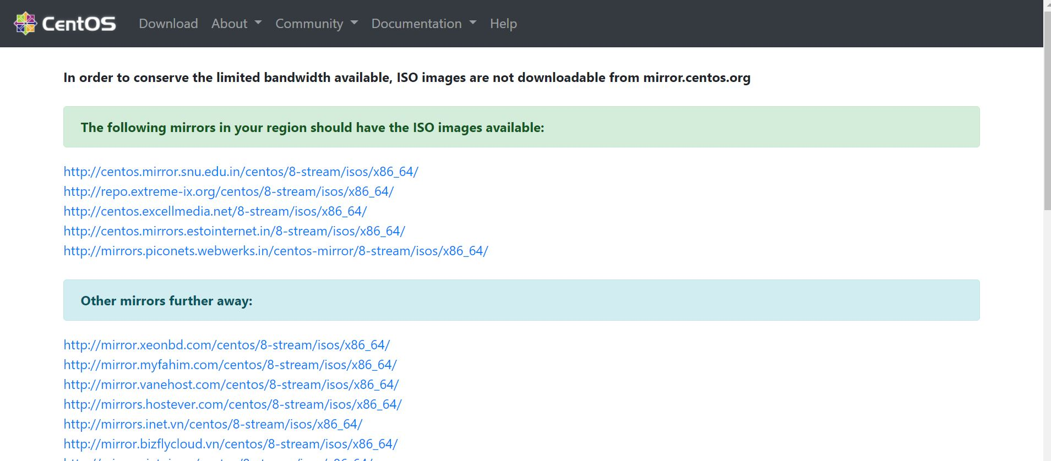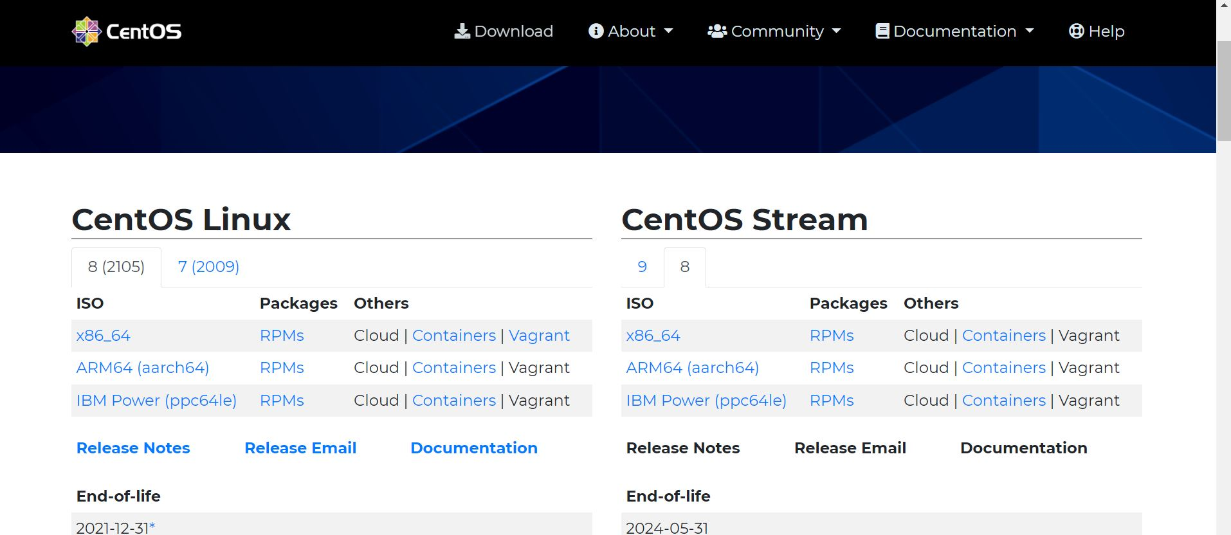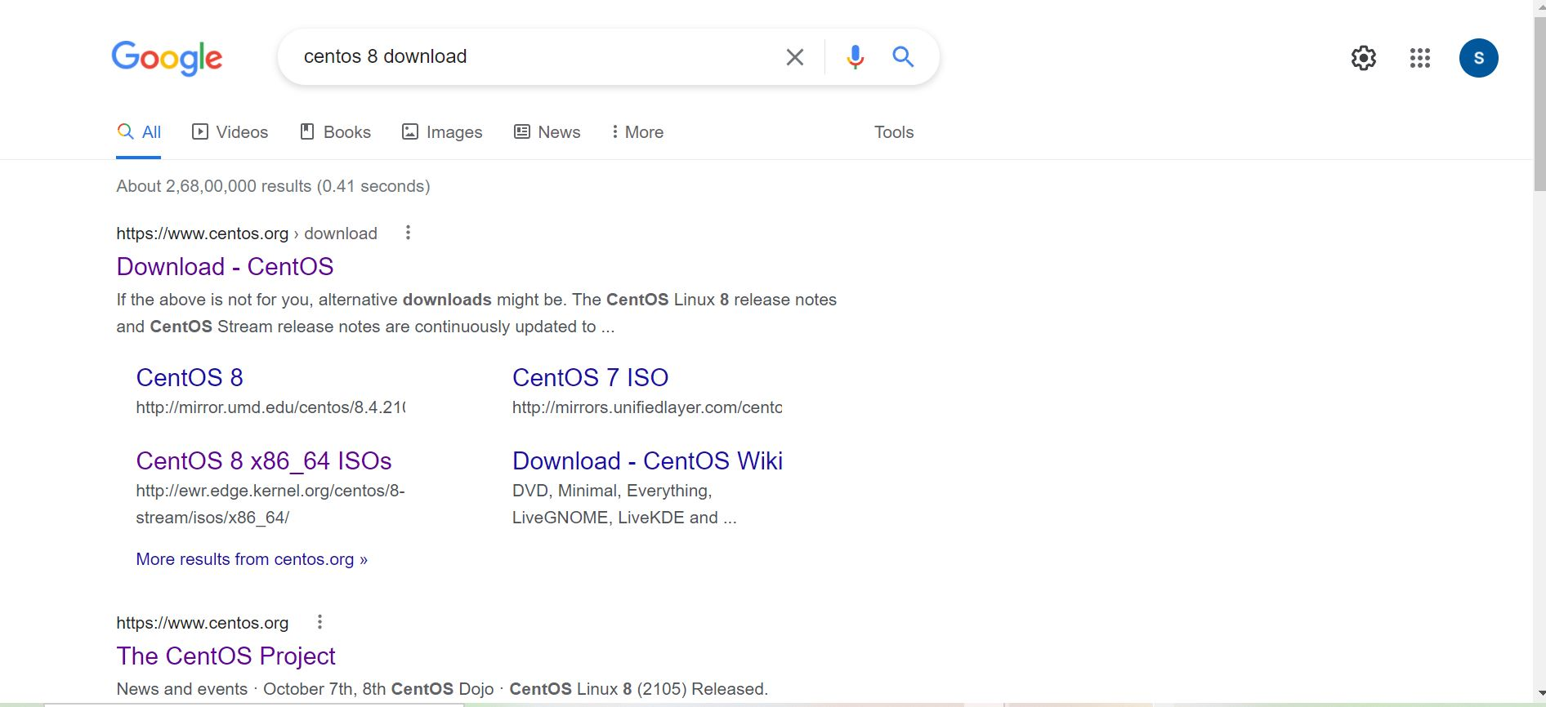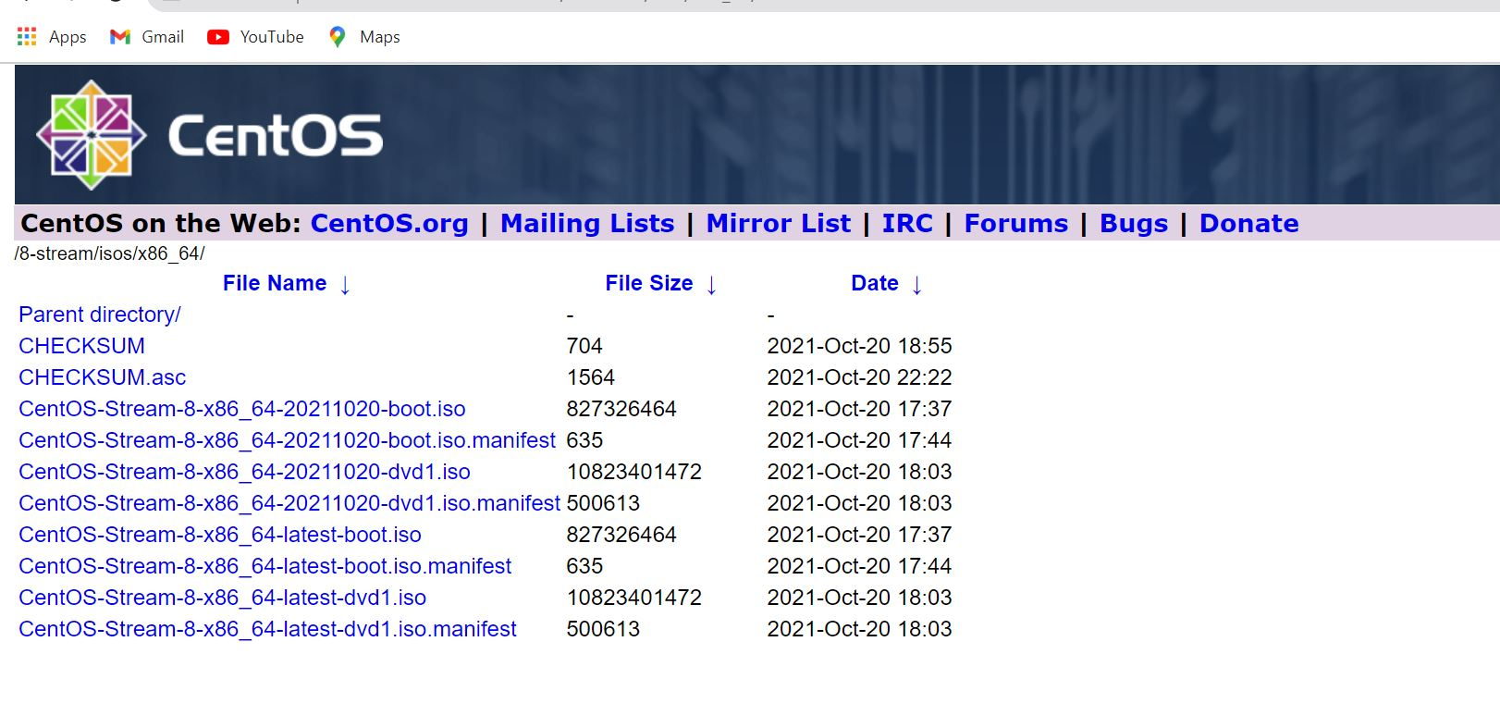

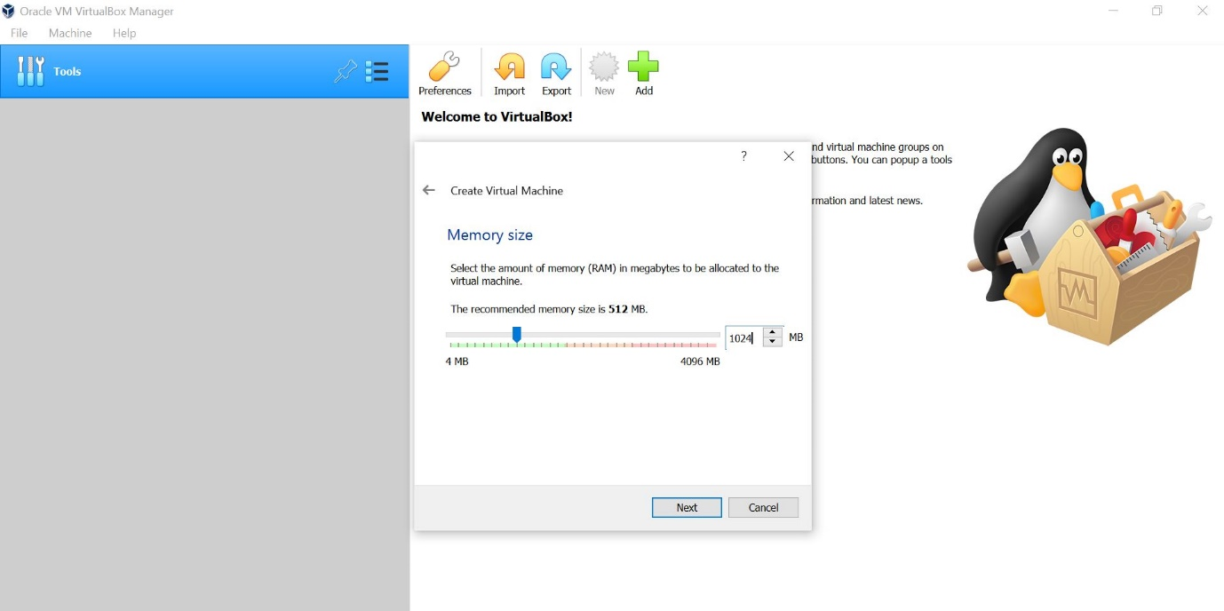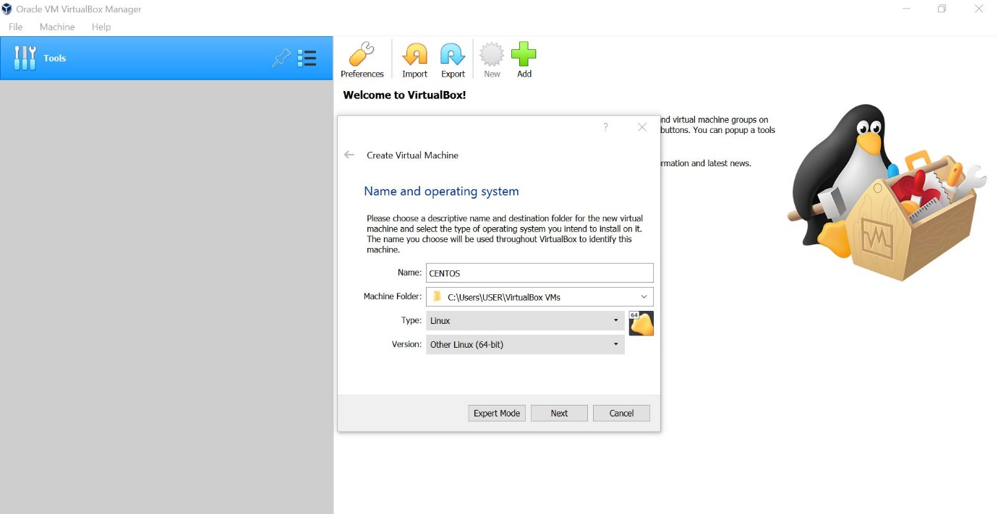

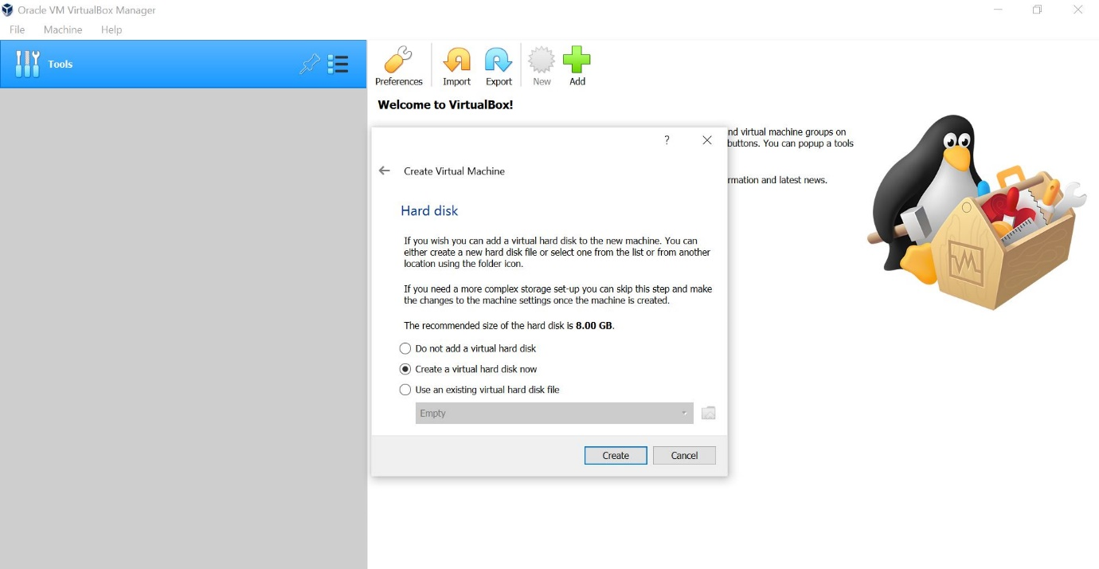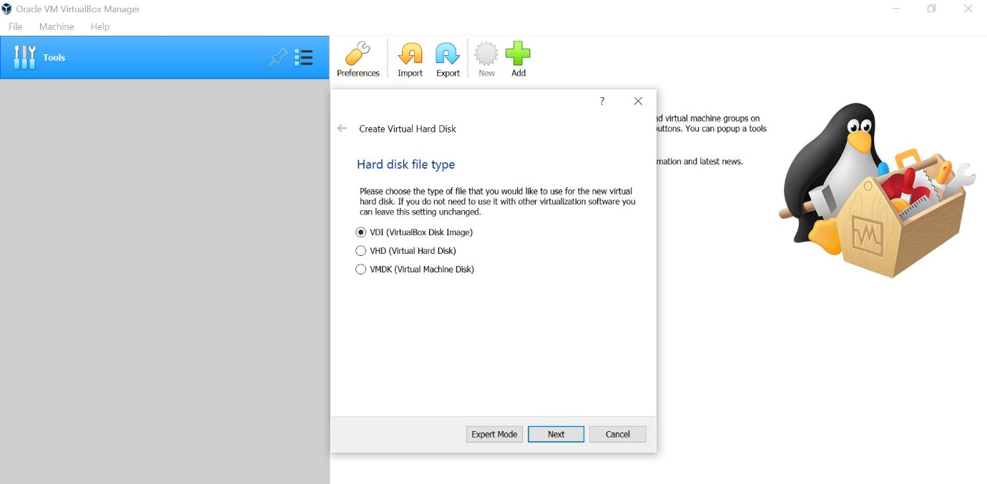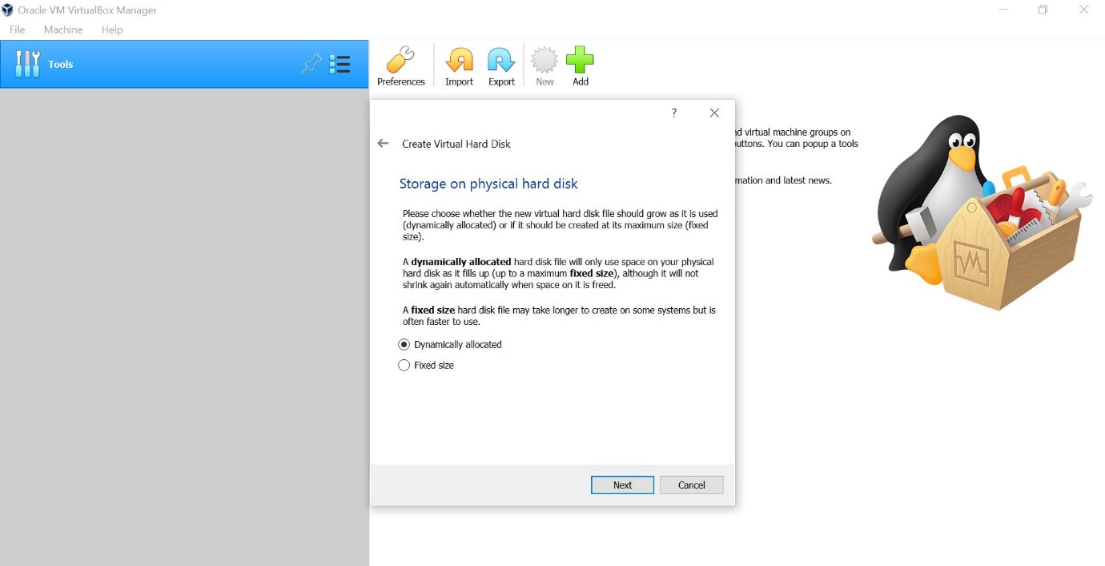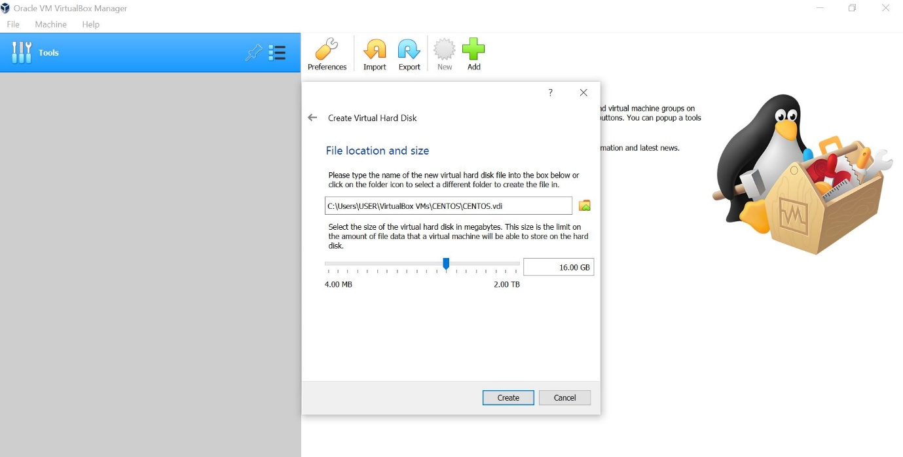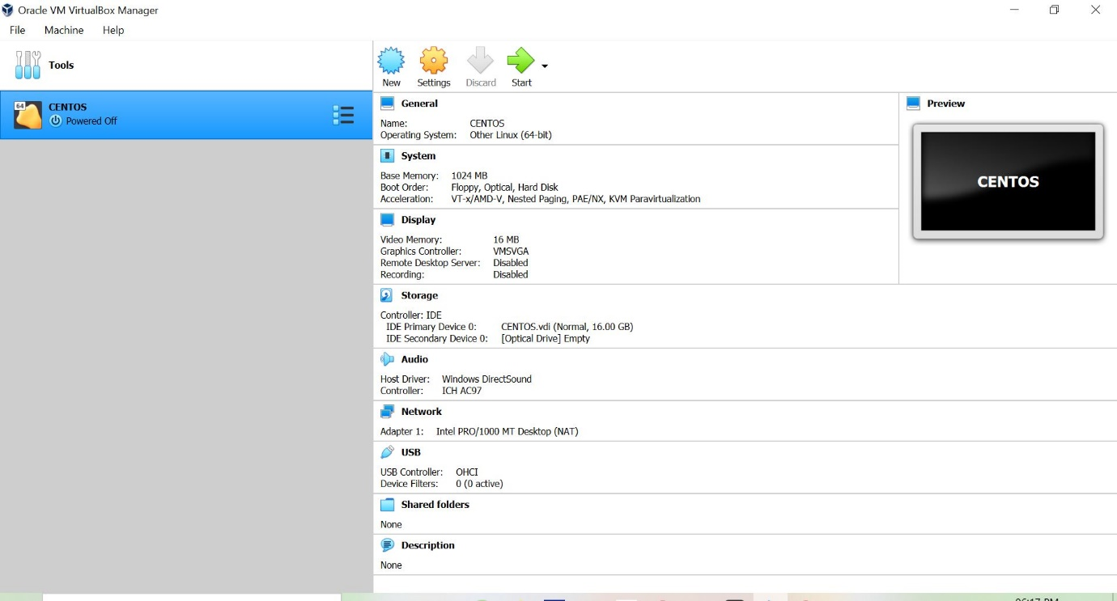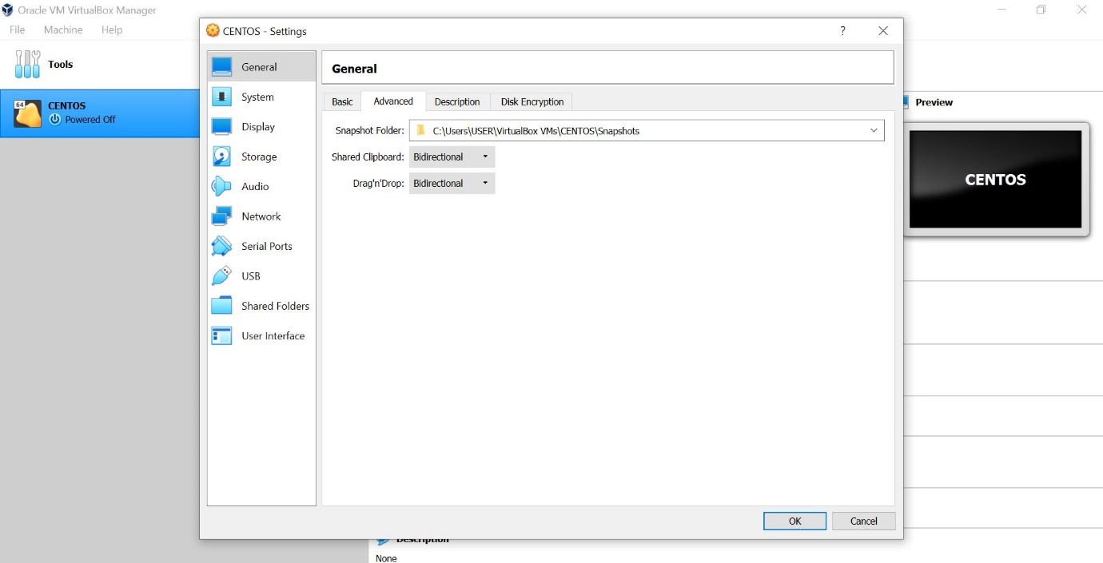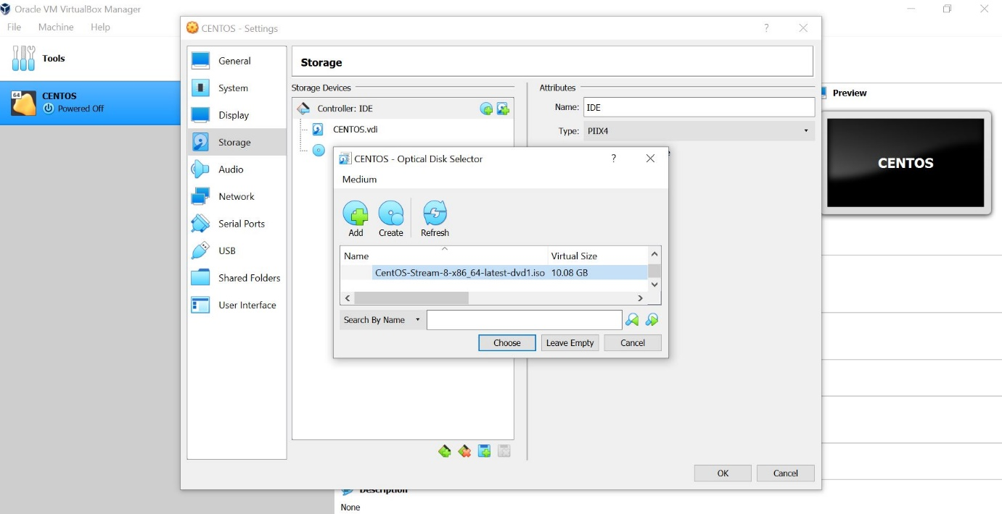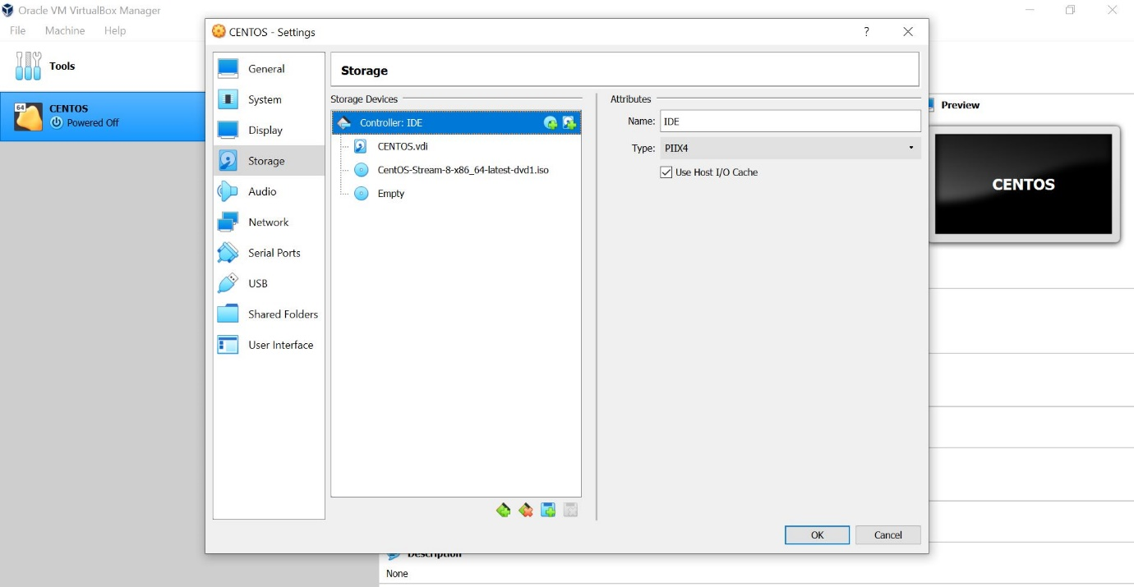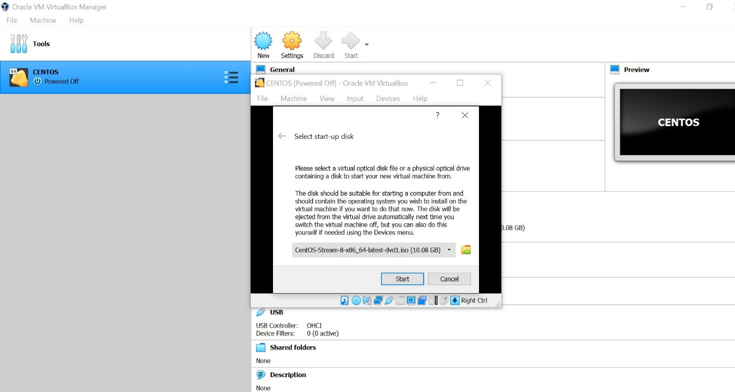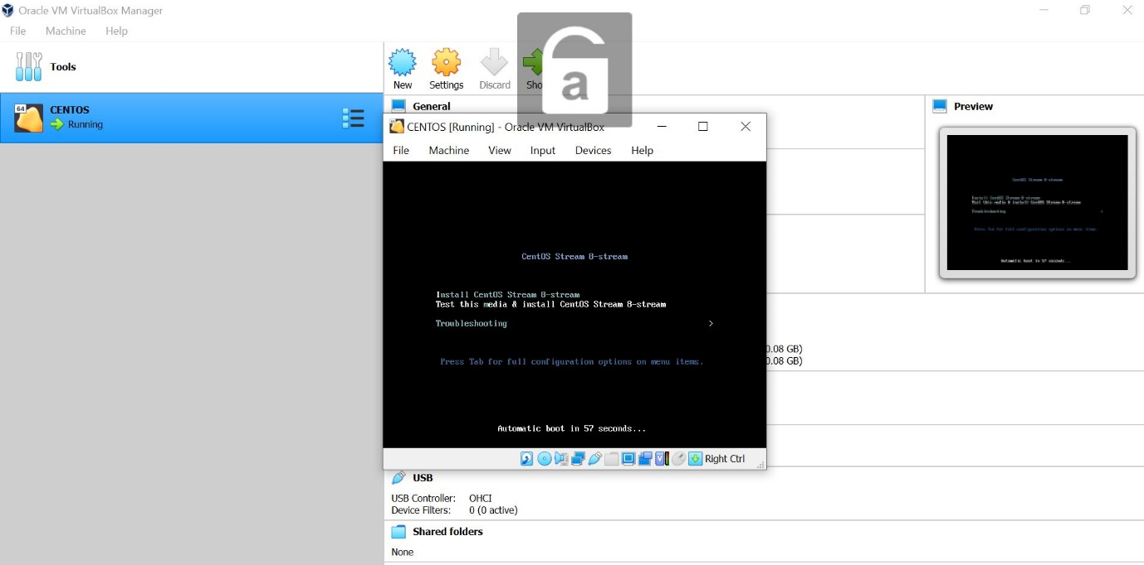

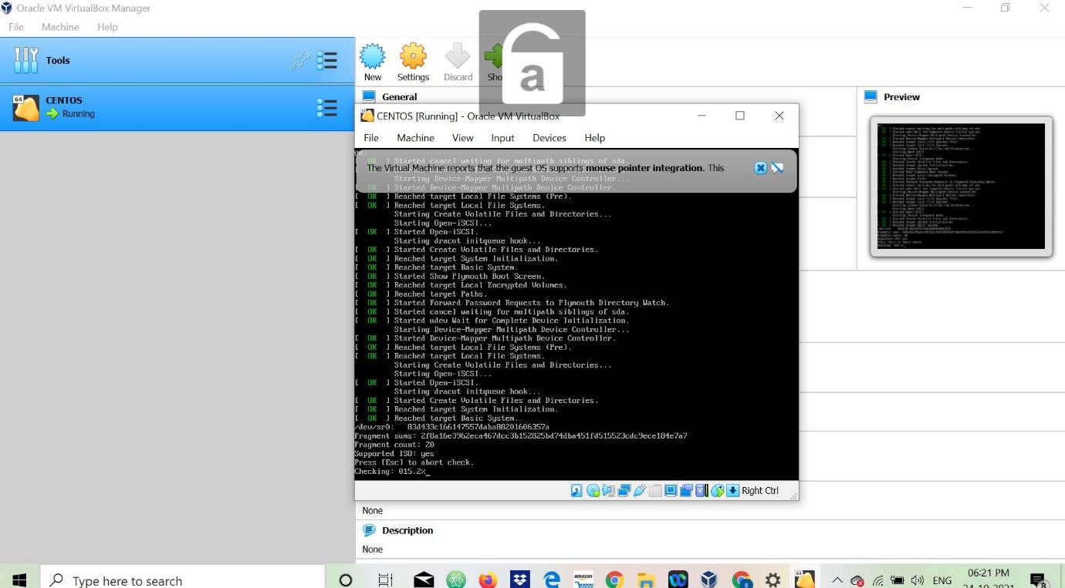

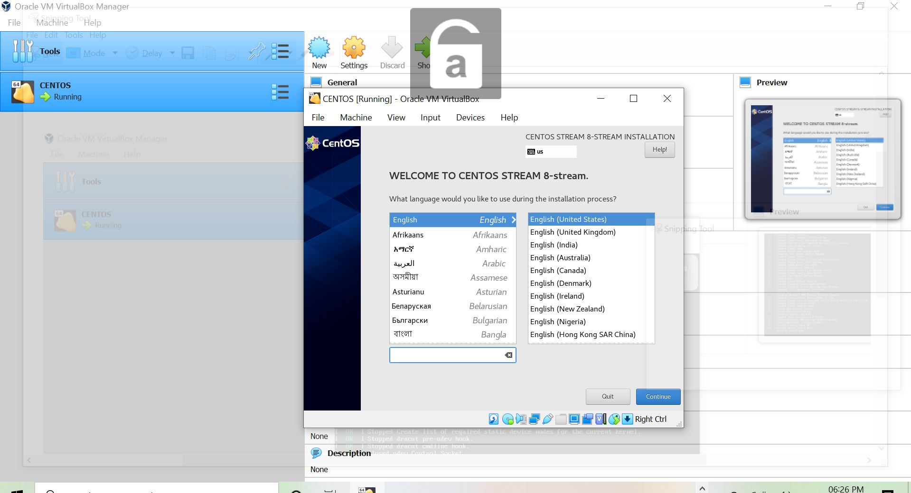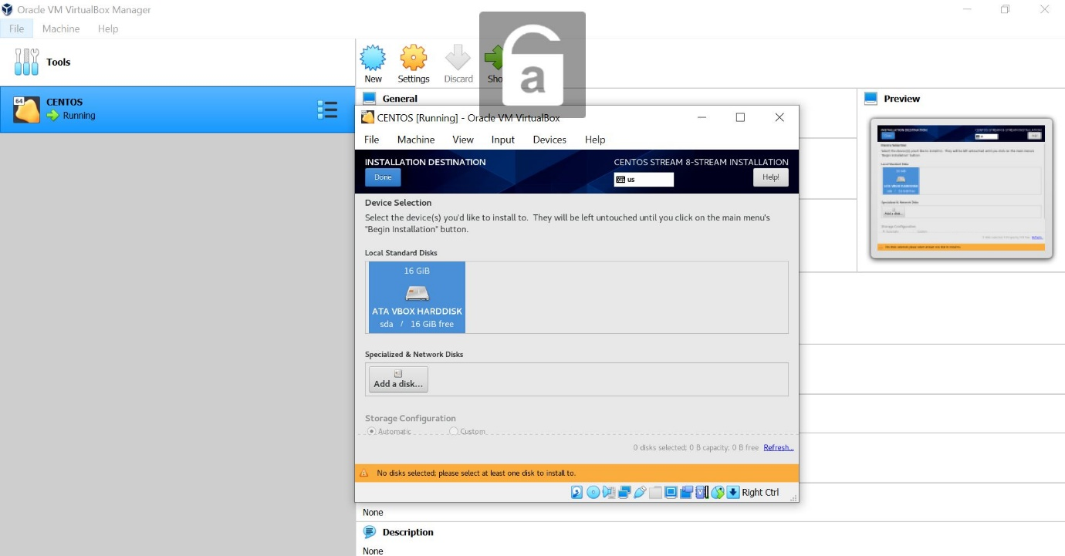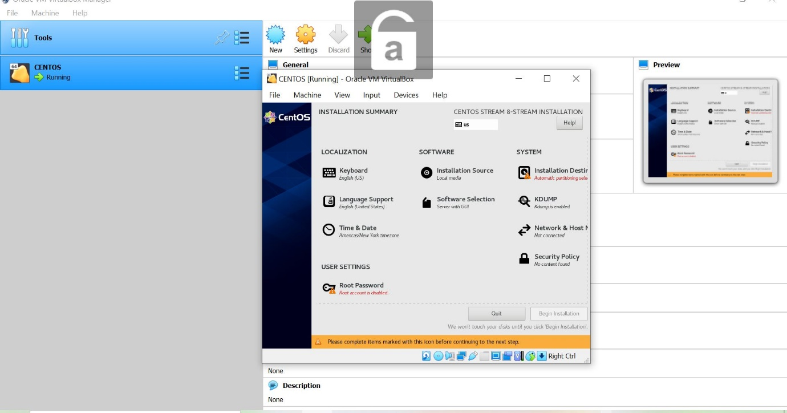

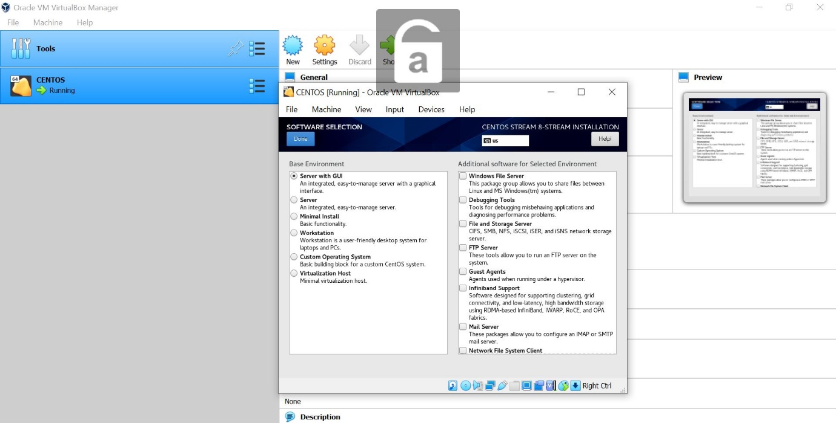

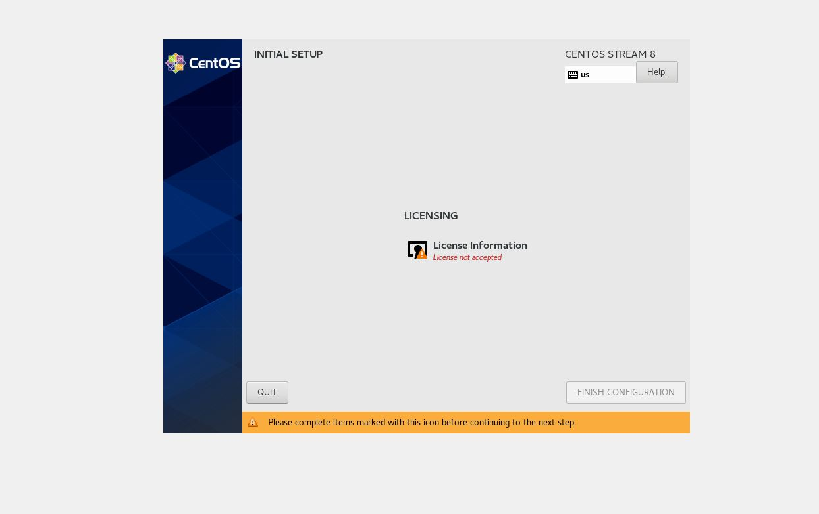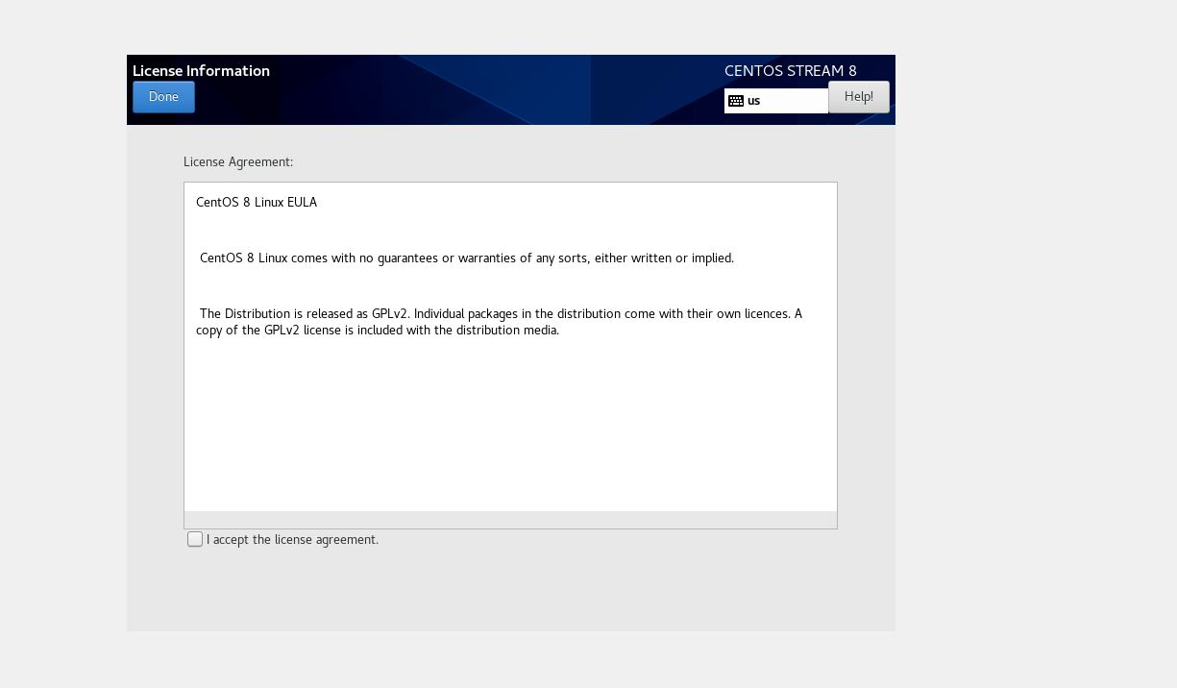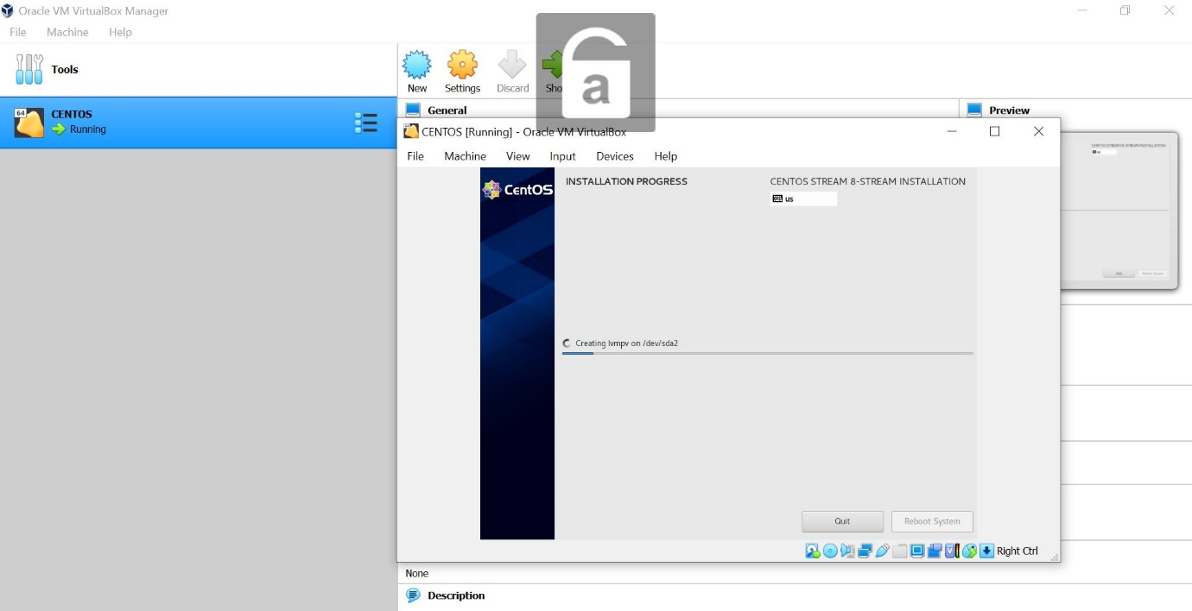

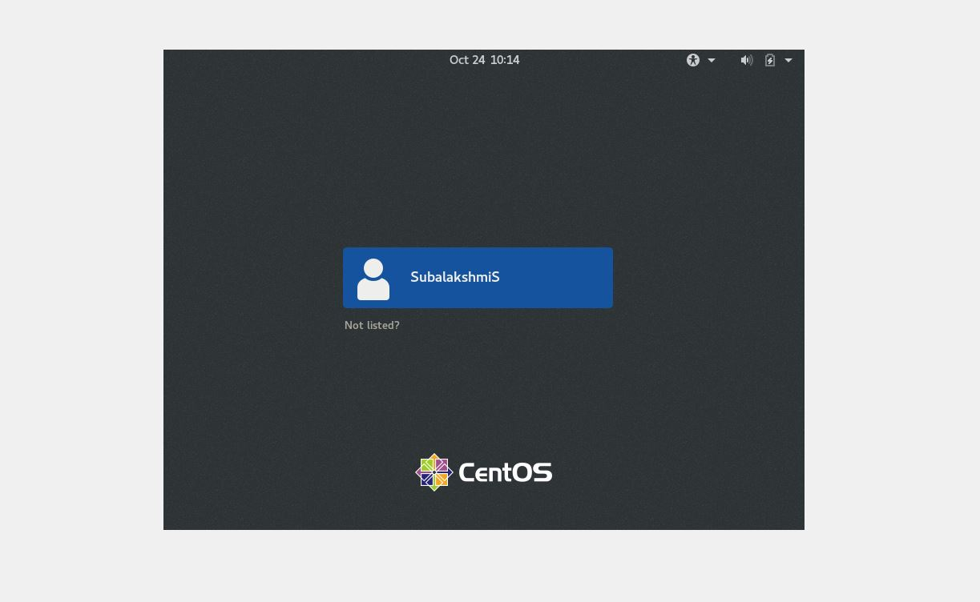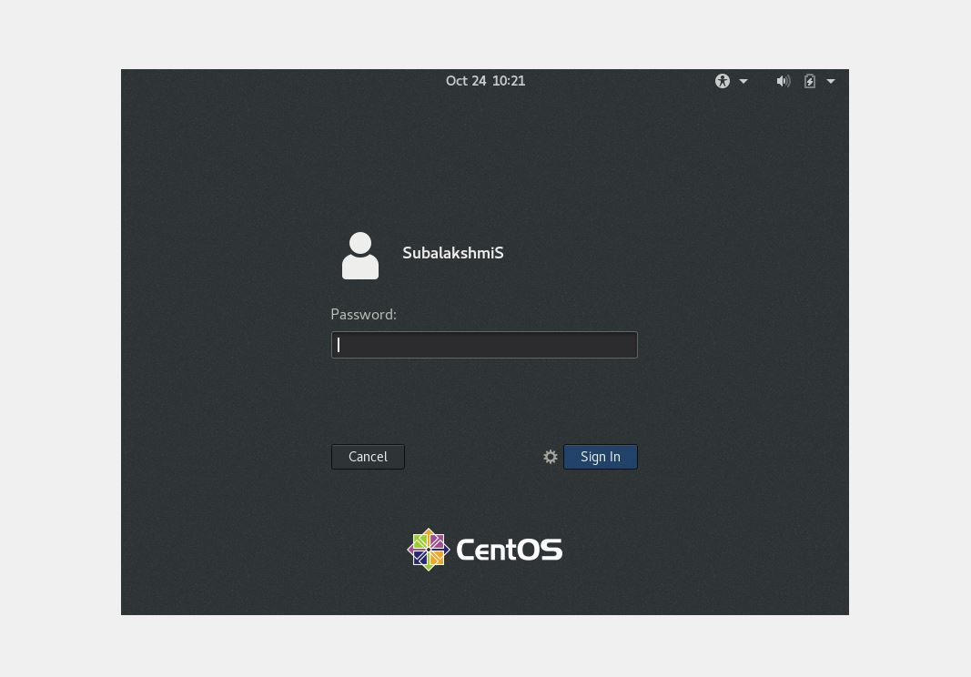



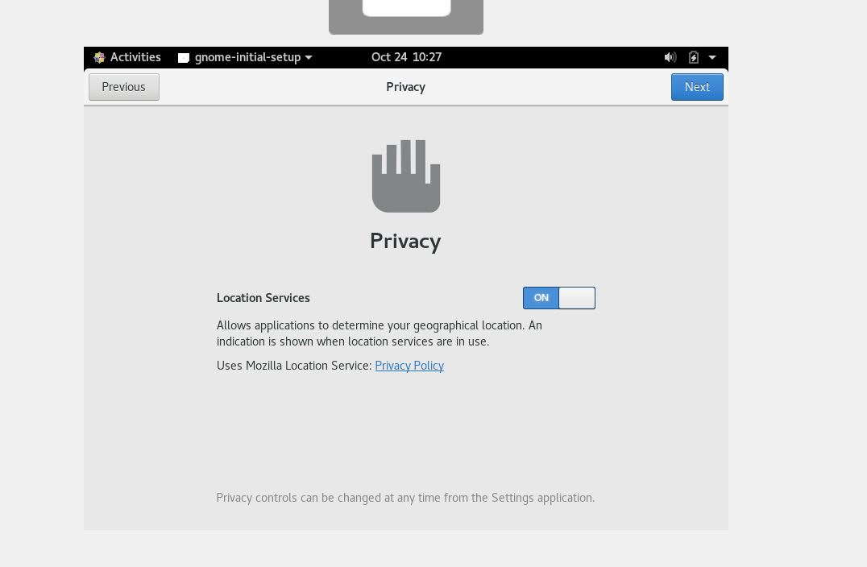

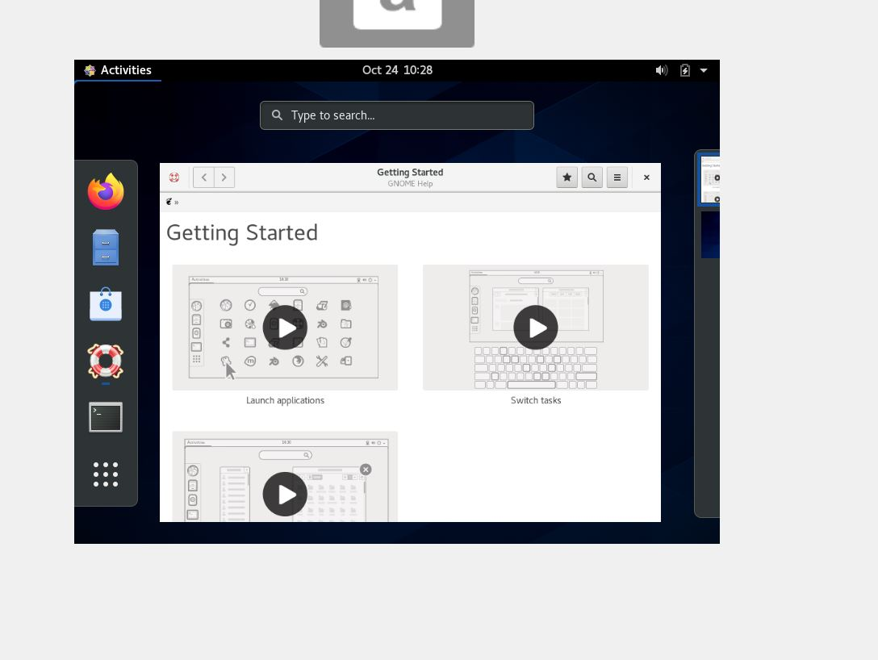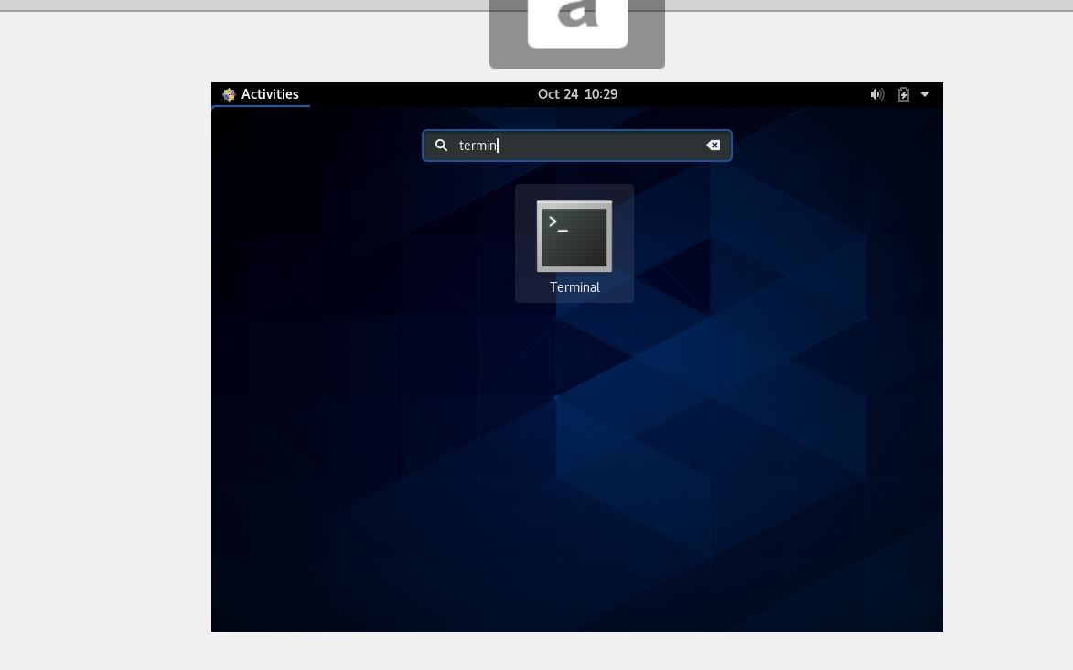

**INSTALLED GCC**

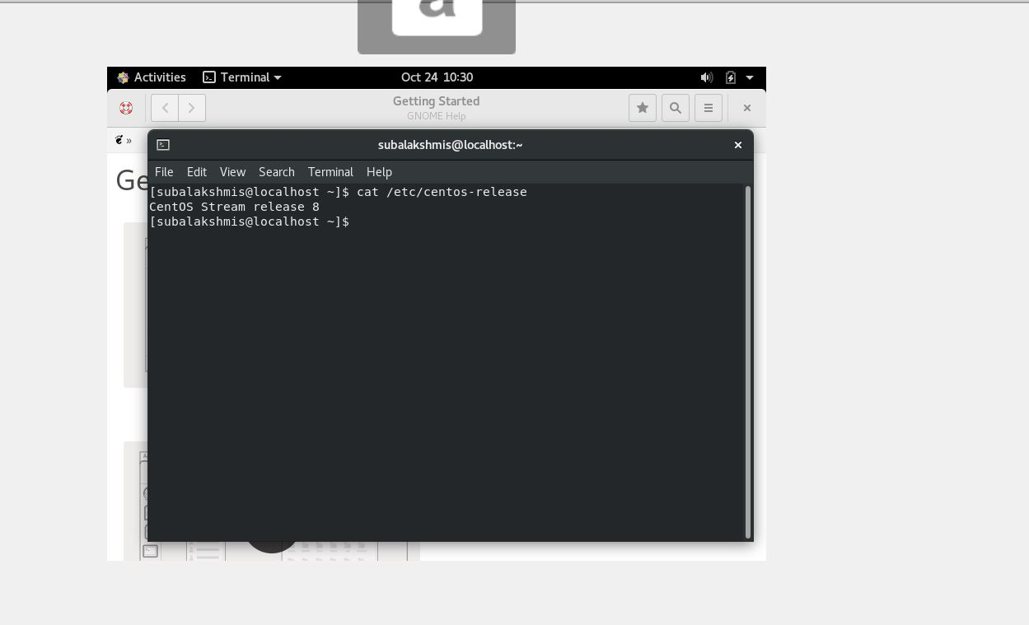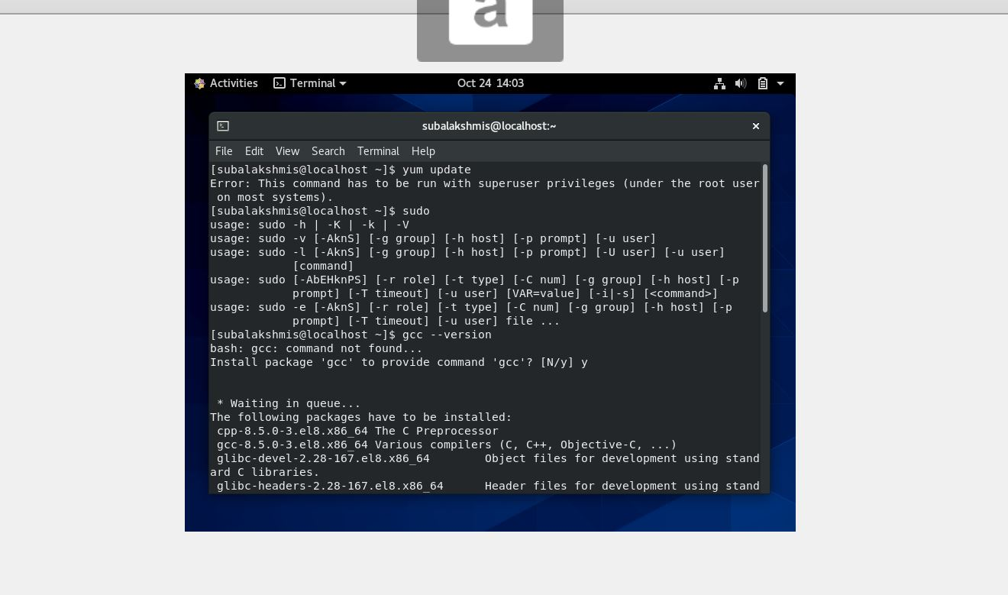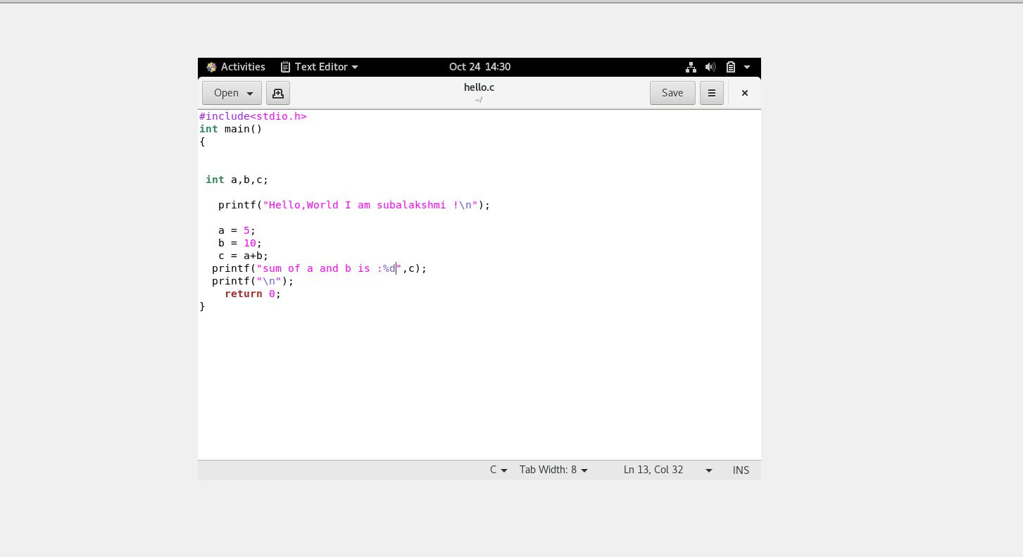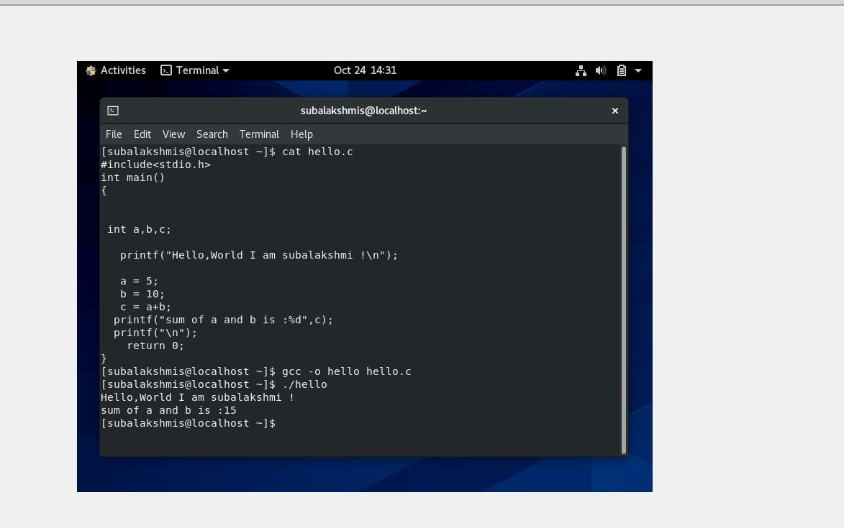

**RASPBERRY PI OS**

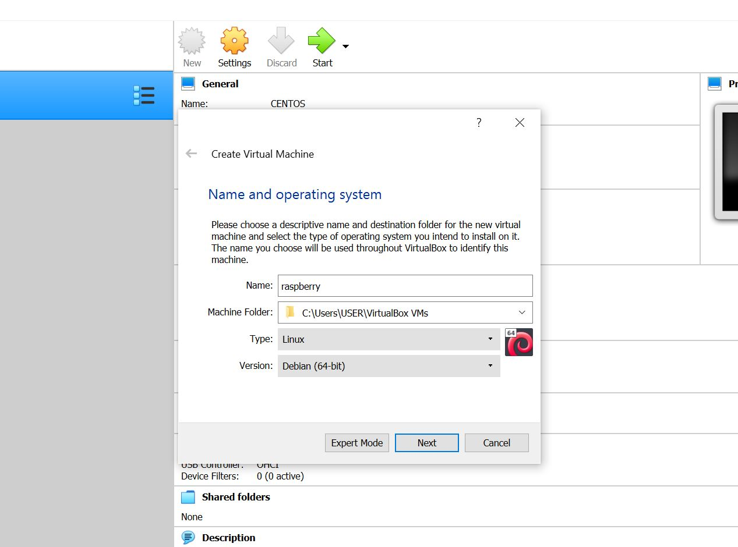

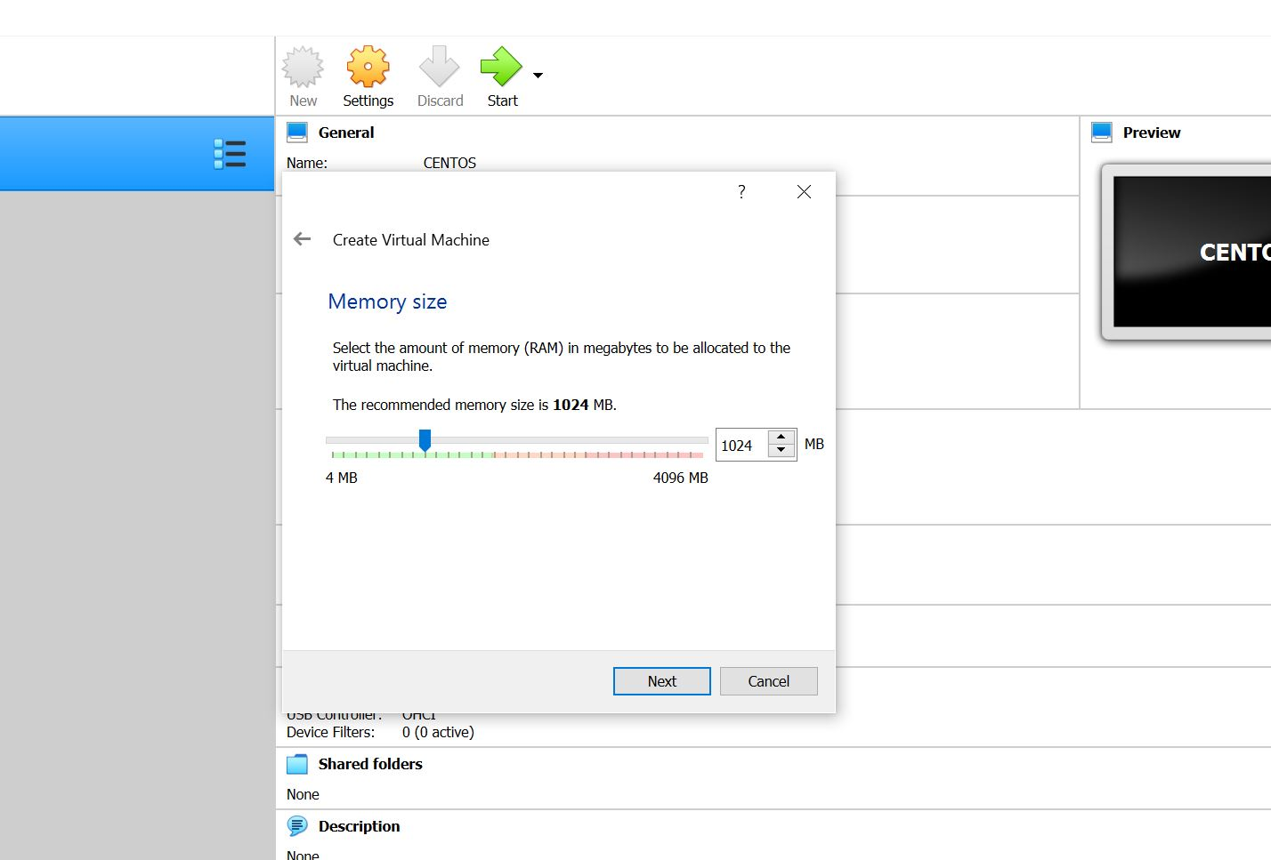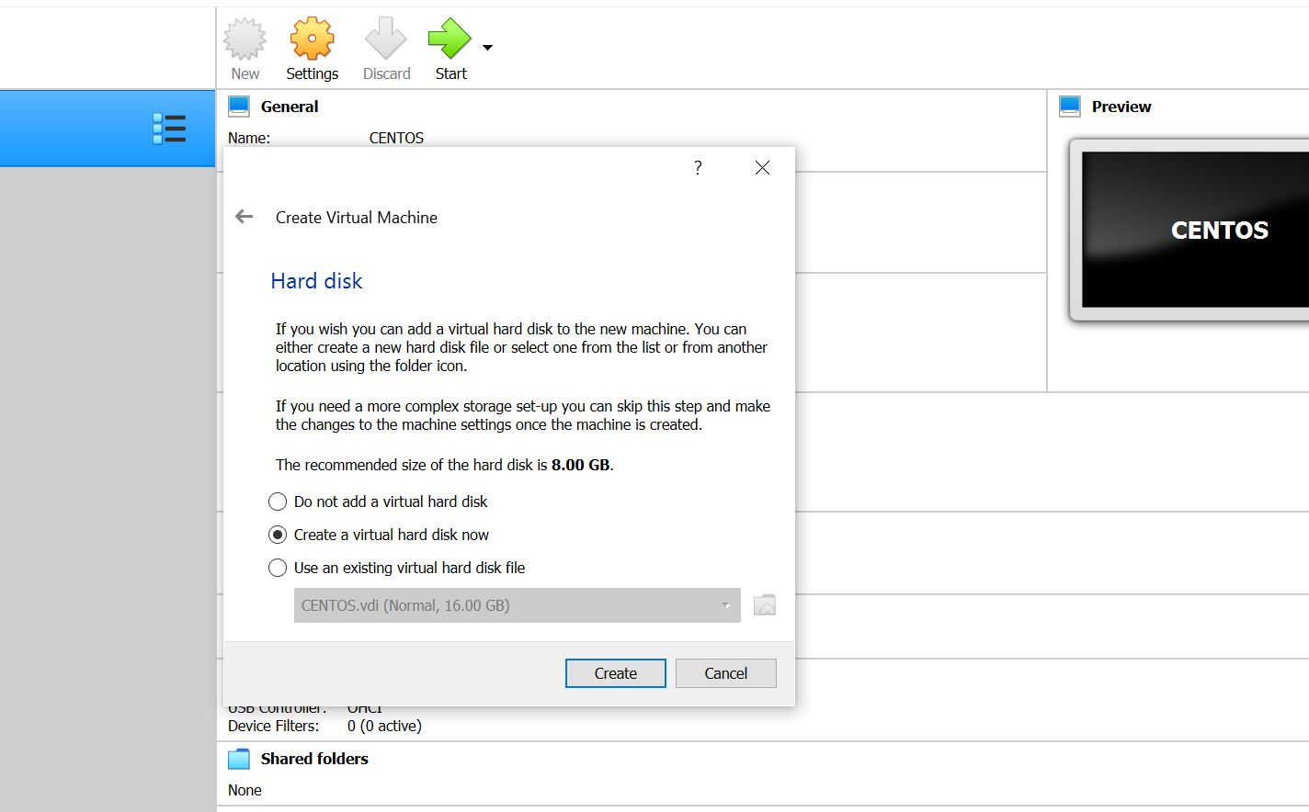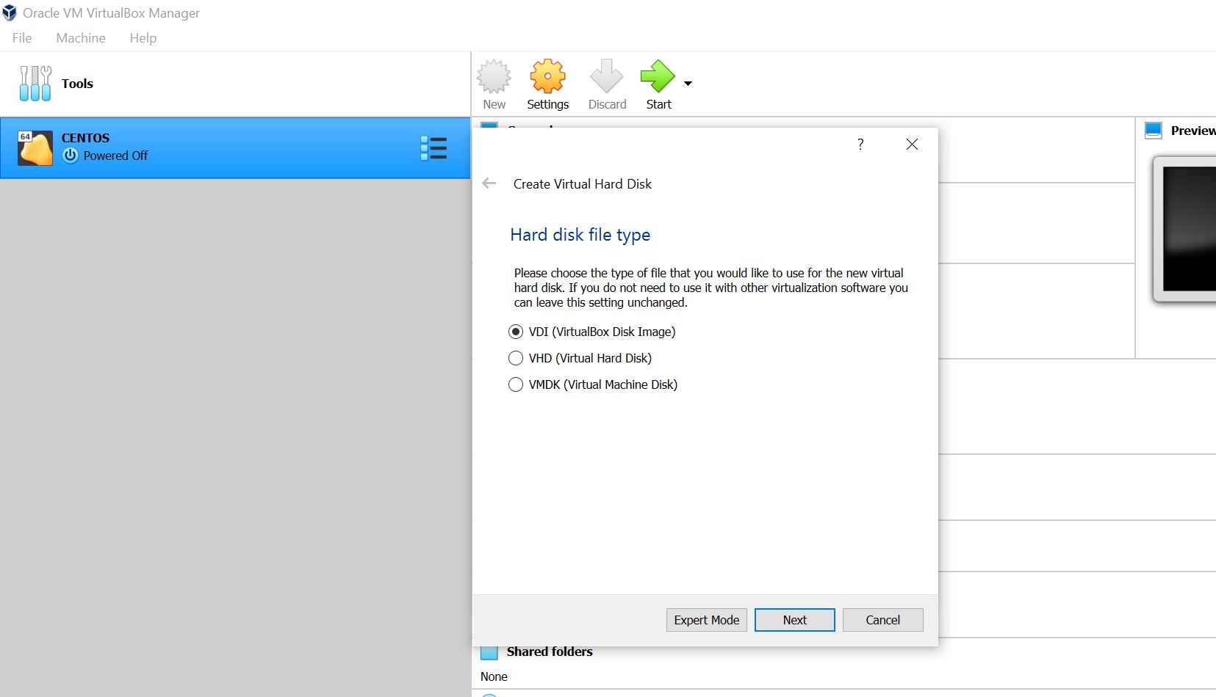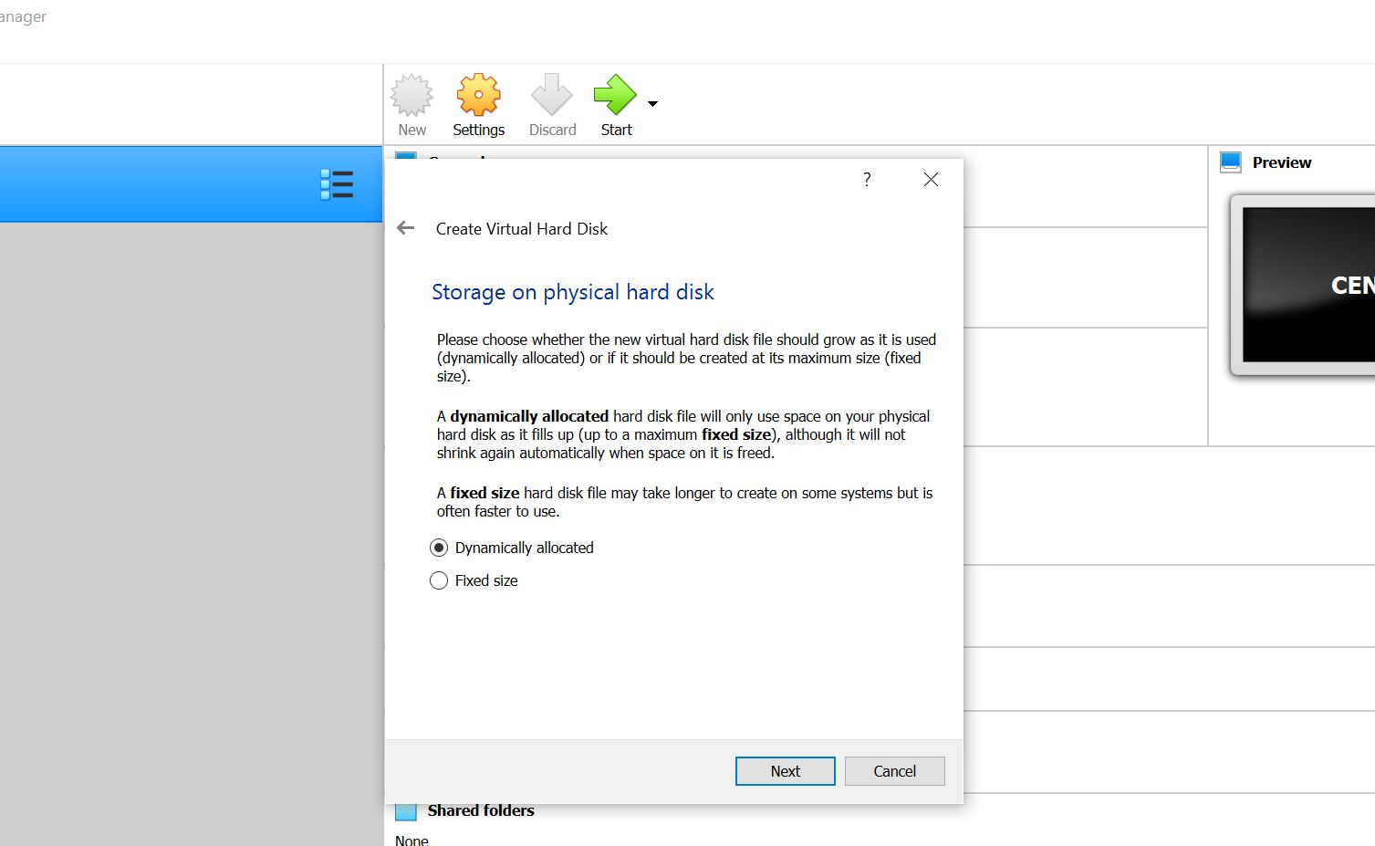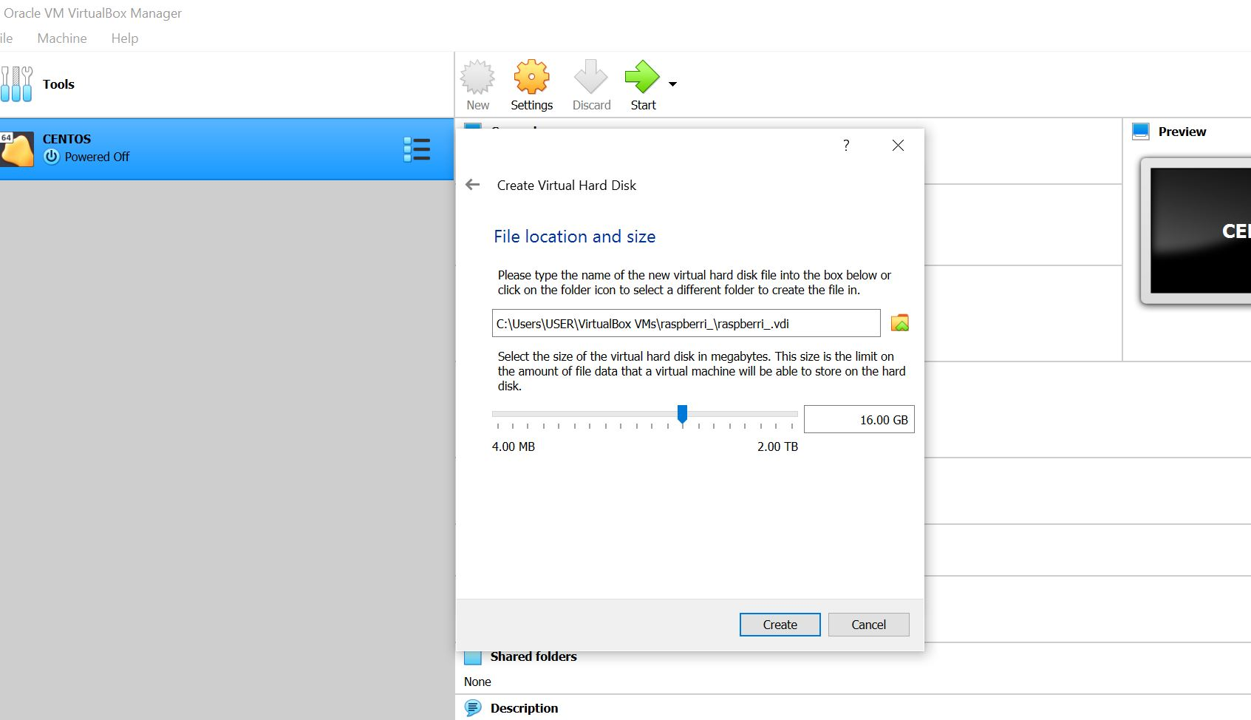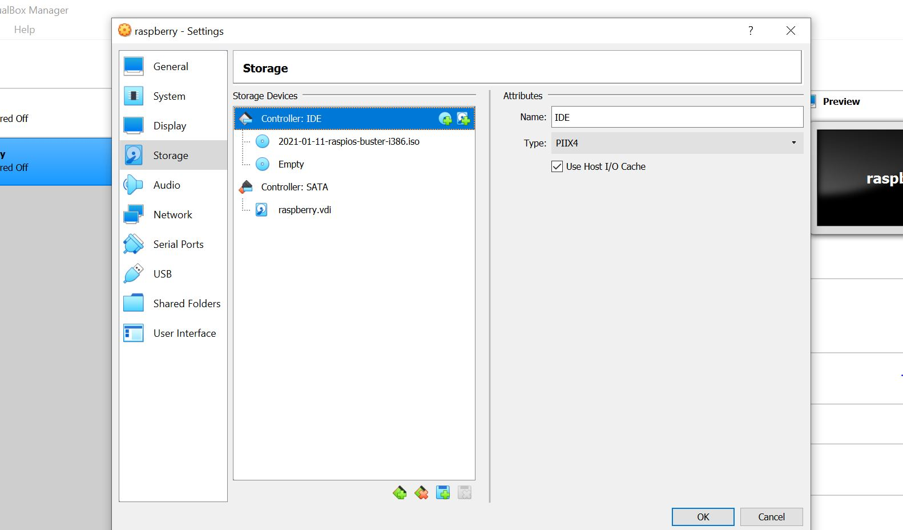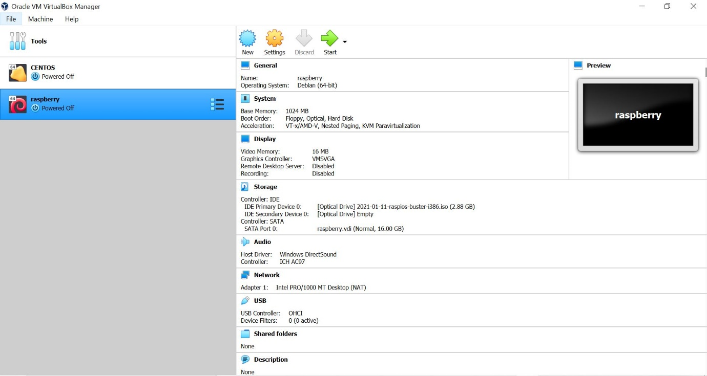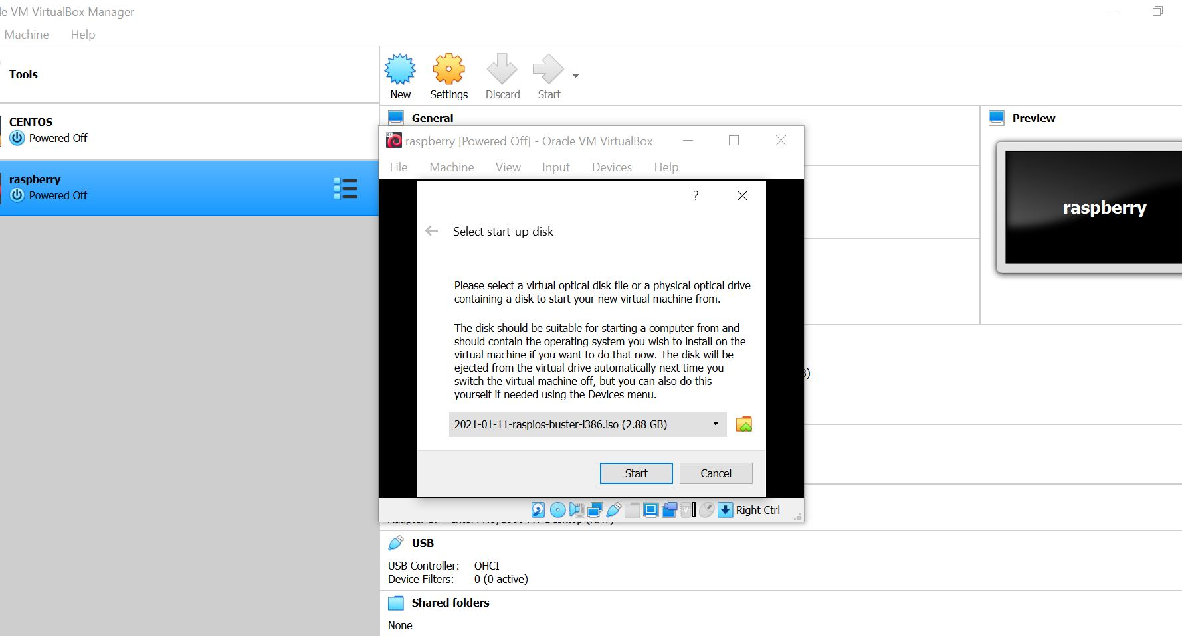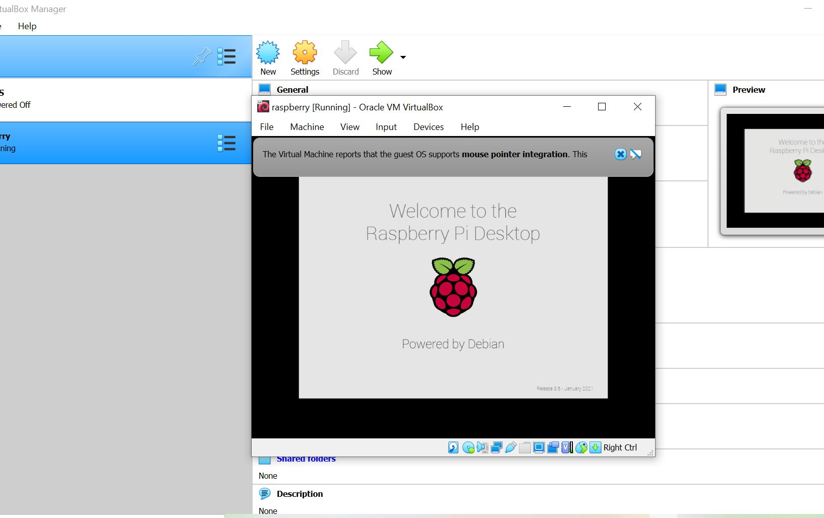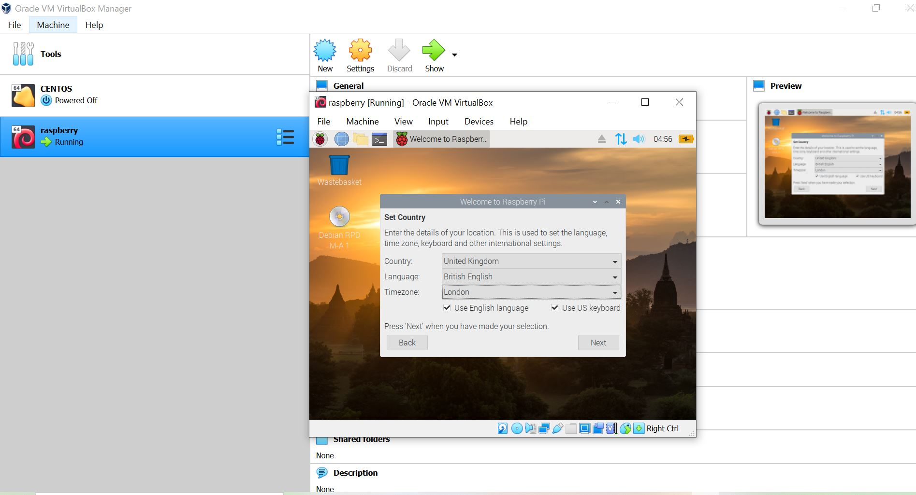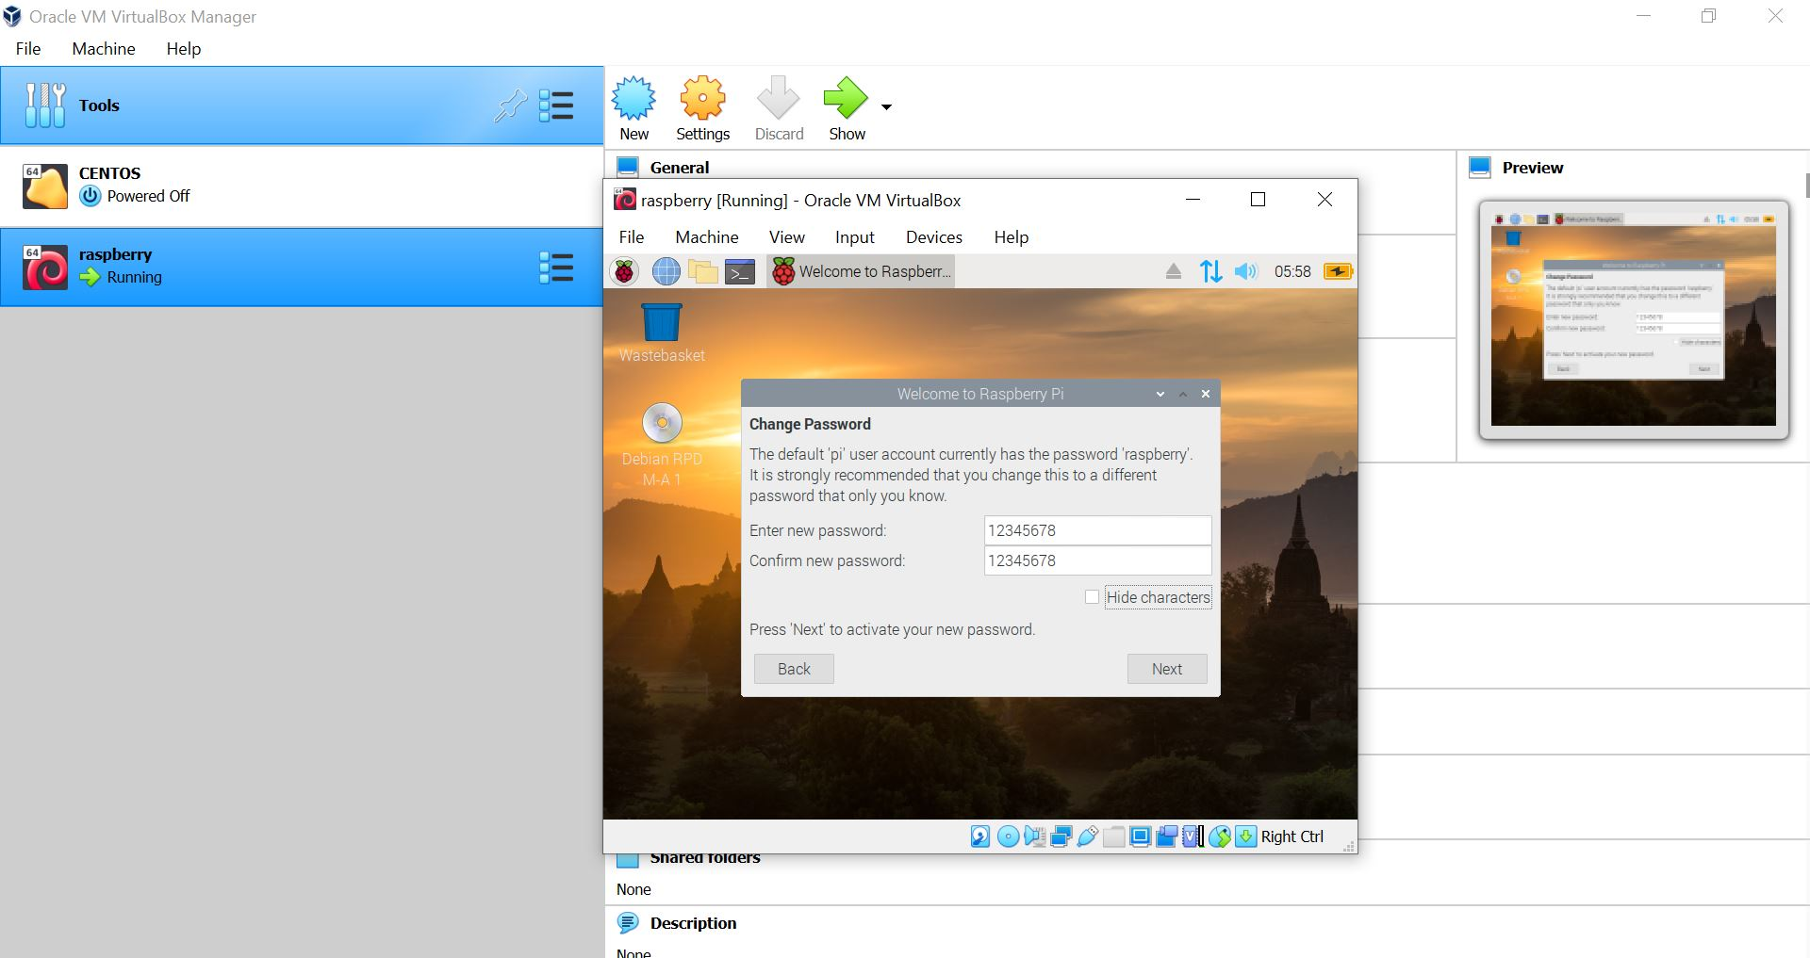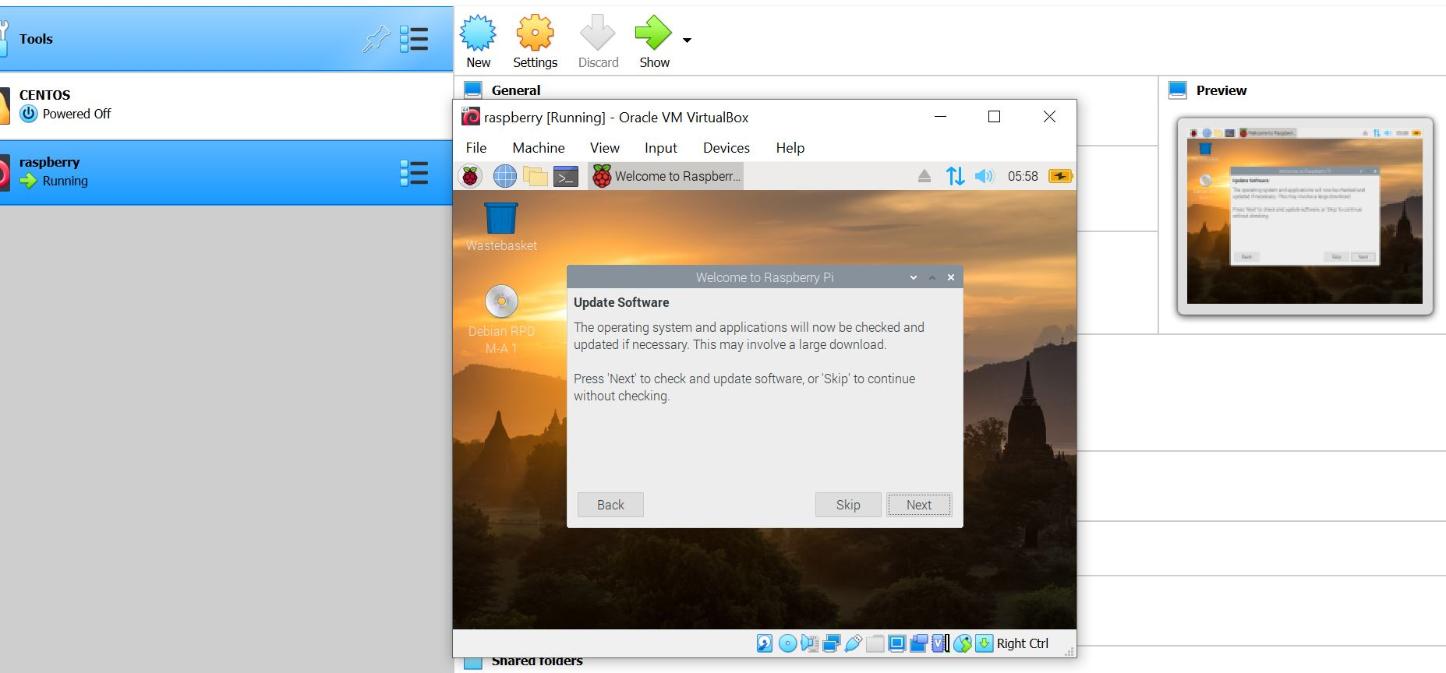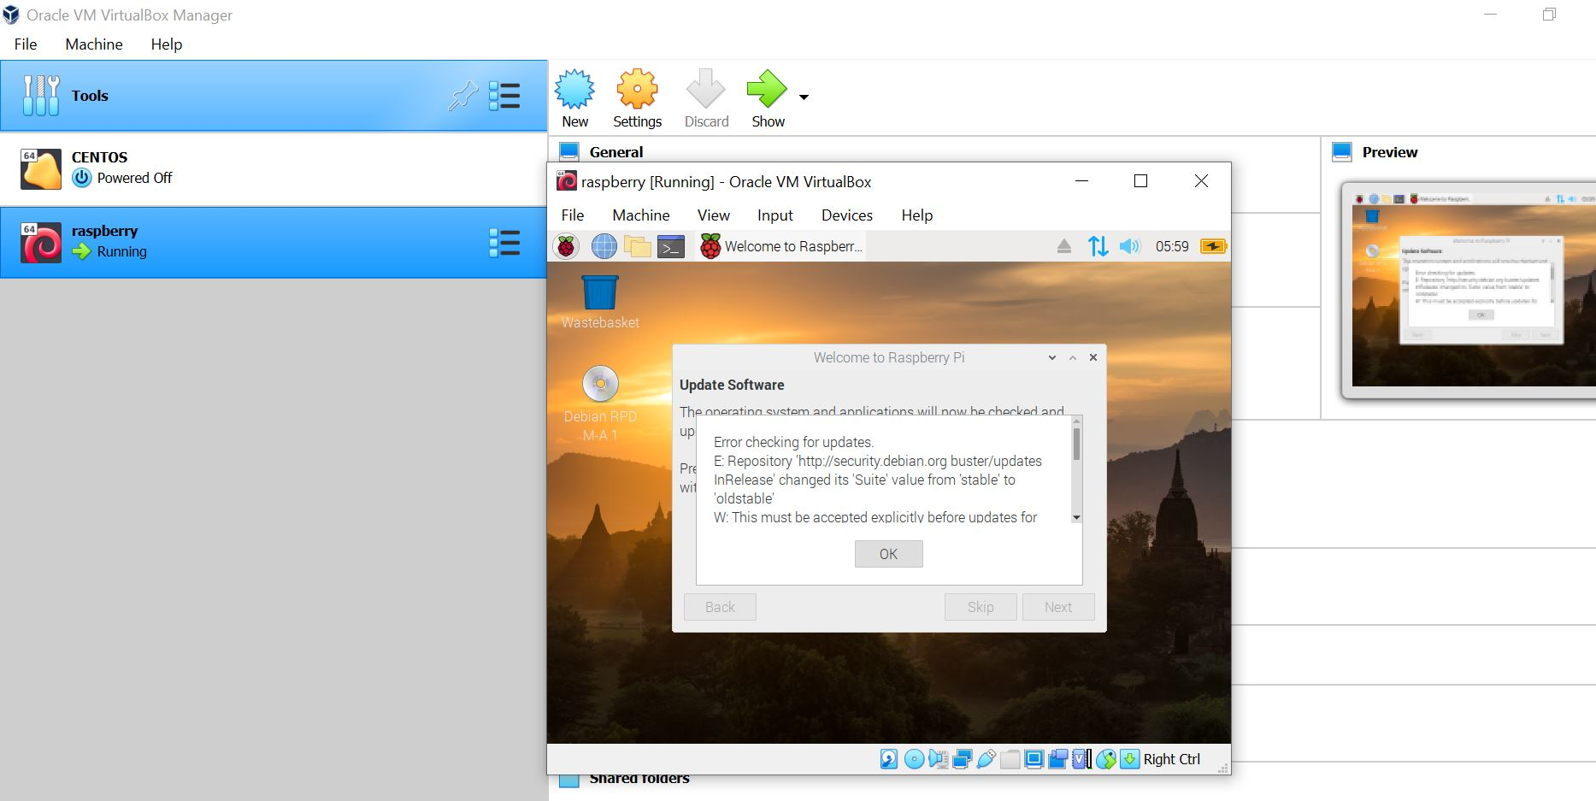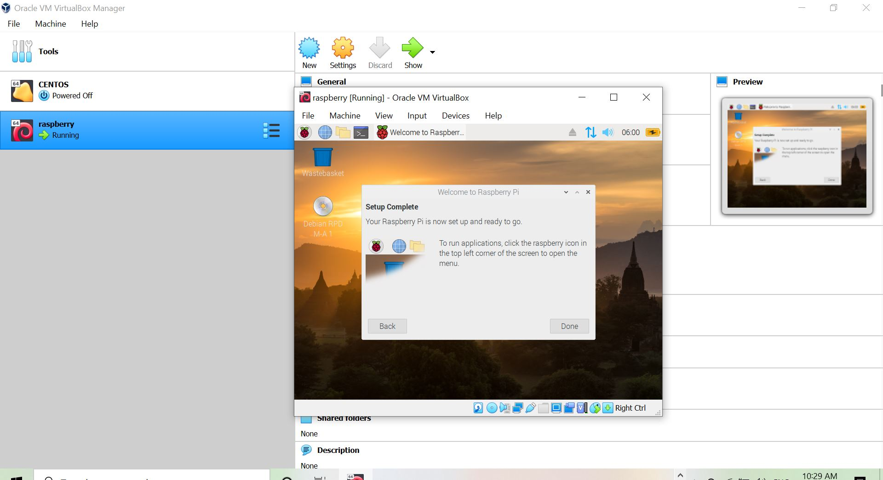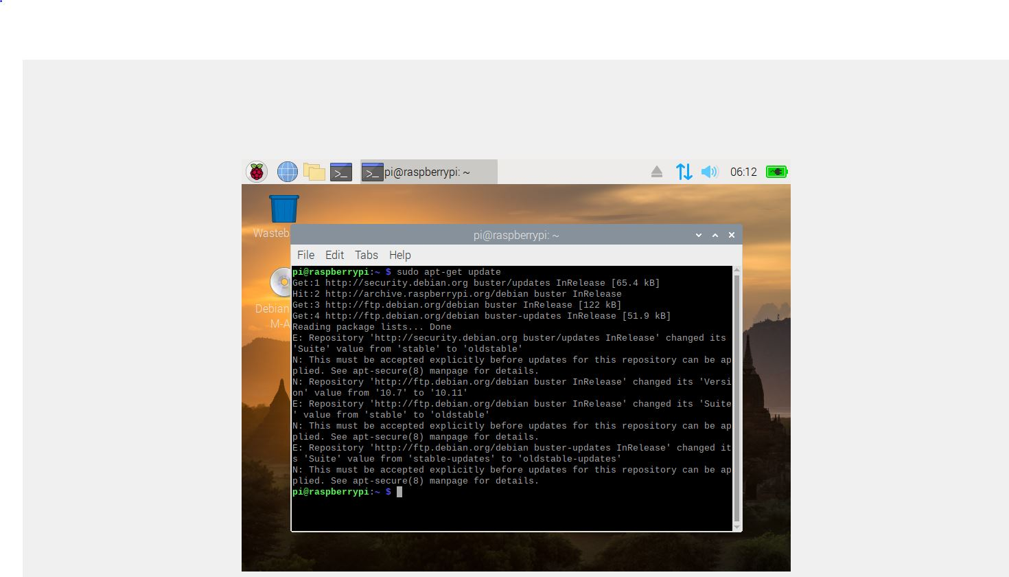

**Installed R studio**

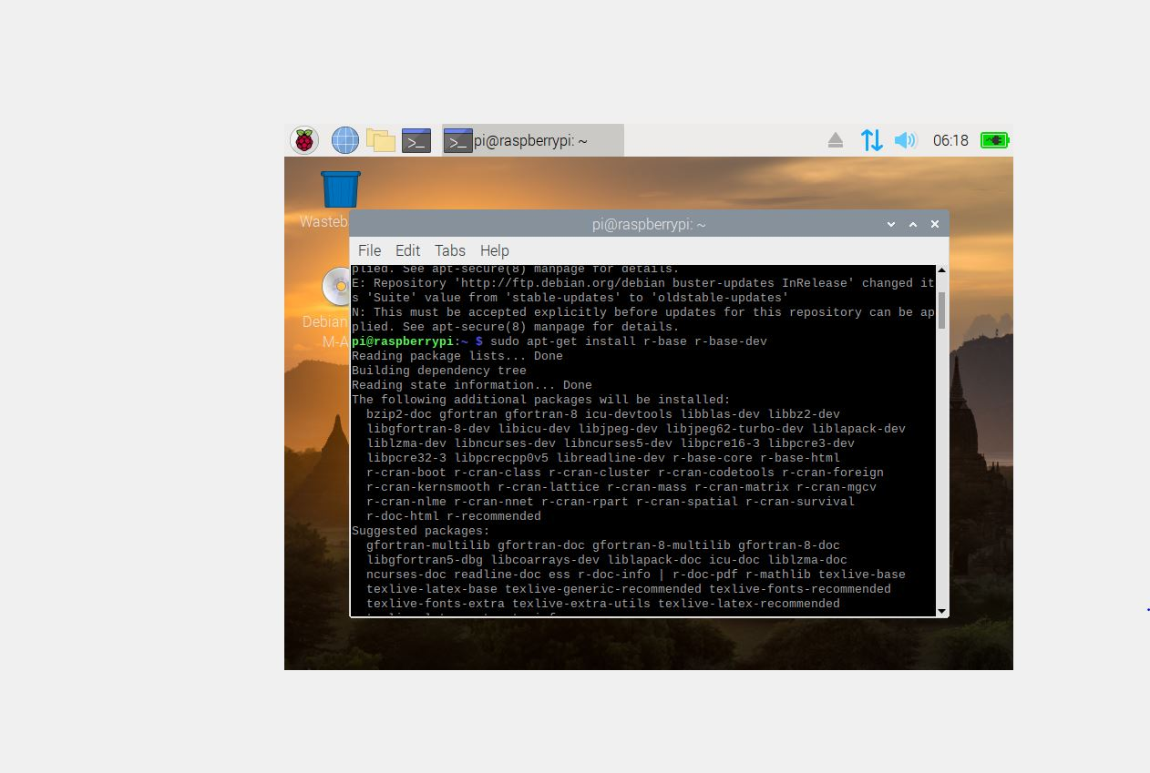

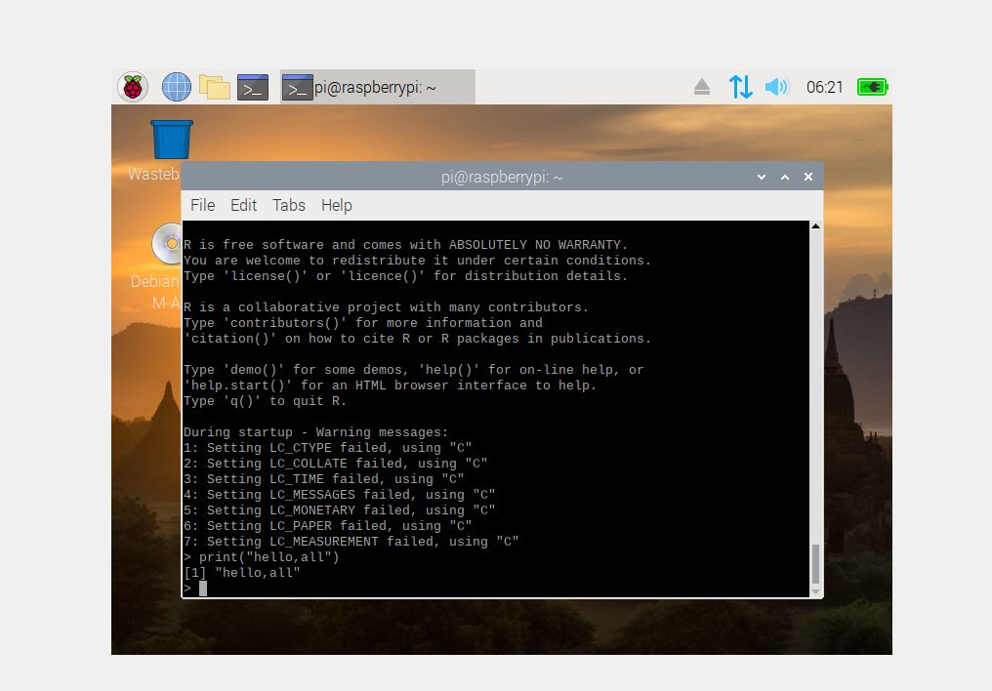

1. What is Kernel?

A Kernel is a computer program that is the heart and core of an Operating System. Since the Operating System has control over the system so, the Kernel also has control over everything in the system. It is the most important part of an Operating System. Whenever a system starts, the Kernel is the first program that is loaded after the bootloader because the Kernel has to handle the rest of the thing of the system for the Operating System. The Kernel remains in the memory until the Operating System is shut-down.

The Kernel is responsible for low-level tasks such as disk management, memory management, task management, etc. It provides an interface between the user and the hardware components of the system. When a process makes a request to the Kernel, then it is called System Call.

A Kernel is provided with a protected Kernel Space which is a separate area of memory and this area is not accessible by other application programs. So, the code of the Kernel is loaded into this protected Kernel Space. Apart from this, the memory used by other applications is called the User Space. As these are two different spaces in the memory, so communication between them is a bit slower.

Kernel Function

* A Kernel can access various computer resources like the CPU, I/O devices and other resources. It acts as a bridge between the user and the resources of the system.
* It is the duty of a Kernel to share the resources between various process in such a way that there is uniform access to the resources by every process.
* Every process needs some memory space. So, memory must be allocated and deallocated for its execution. All these memory management is done by a Kernel.
* The peripheral devices connected in the system are used by the processes. So, the allocation of these devices is managed by the Kernel.

1. What is shell?

A shell is software that provides an interface for an operating system's users to provide access to the kernel's services.

On Unix-based or Linux-based operating systems, a shell can be invoked through the shell command in the command line interface (CLI), allowing users to direct operations through computer commands, text or script.

Shells also exist for programming languages, providing them with autonomy from the operating system and allowing cross-platform compatibility.

1. What is OS?

An Operating System is the most important program that is first loaded on a computer when you first switch on the system. The communication between a user and a system takes place with the help of an operating system. It translates the instructions given by the user in a high-level language to machine language, which a computer can understand. It acts as an intermediary between a user and computer hardware and provides an environment required to execute different programs efficiently.

1. What are the components of an OS?

The components of an operating system play a key role to make a variety of computer system parts work together. There are the following components of an operating system, such as:

1. Process Management
2. File Management
3. Network Management
4. Main Memory Management
5. Secondary Storage Management
6. I/O Device Management
7. Security Management
8. Command Interpreter System
9. **Process Management**

The process management component is a procedure for managing many processes running simultaneously on the operating system. Every running software application program has one or more processes associated with them.

1. **File Management**

A file is a set of related information defined by its creator. It commonly represents programs (both source and object forms) and data. Data files can be alphabetic, numeric, or alphanumeric.

1. **Network Management**

Network management is the process of administering and managing computer networks. It includes performance management, provisioning of networks, fault analysis, and maintaining the quality of service.

1. **Main memory Management**

Main memory is a large array of storage or bytes, which has an address. The memory management process is conducted by using a sequence of reads or writes of specific memory addresses.

It should be mapped to absolute addresses and loaded inside the memory to execute a program. The selection of a memory management method depends on several factors.

it is mainly based on the hardware design of the system. Each algorithm requires corresponding hardware support. Main memory offers fast storage that can be accessed directly by the CPU. It is costly and hence has a lower storage capacity. However, for a program to be executed, it must be in the main memory.

1. **Secondary-storage Management**

The most important task of a computer system is to execute programs. These programs help you to access the data from the main memory during execution. This memory of the computer is very small to store all data and programs permanently. The computer system offers secondary storage to back up the main memory.

Today modern computers use hard drives/SSD as the primary storage of both programs and data. However, the secondary storage management also works with storage devices, such as USB flash drives and CD/DVD drives. Programs like assemblers and compilers are stored on the disk until it is loaded into memory, and then use the disk is used as a source and destination for processing.

1. **I/O Device Management**

One of the important use of an operating system that helps to hide the variations of specific hardware devices from the user.

1. **Security Management**

The various processes in an operating system need to be secured from other activities. Therefore, various mechanisms can ensure those processes that want to operate files, memory CPU, and other hardware resources should have proper authorization from the operating system.

Security refers to a mechanism for controlling the access of programs, processes, or users to the resources defined by computer controls to be imposed, together with some means of enforcement.

Security can improve reliability by detecting latent errors at the interfaces between component subsystems. Early detection of interface errors can prevent the foulness of a healthy subsystem by a malfunctioning subsystem. An unprotected resource cannot misuse by an unauthorized or incompetent user.

1. **Command Interpreter System**

The command interpreter is the primary interface between the user and the rest of the system.

Its function is quite simple, get the next command statement, and execute it. The command statements deal with process management, I/O handling, secondary storage management, main memory management, file system access, protection, and networking.